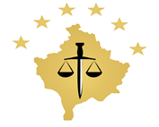
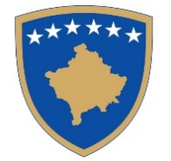

Republika e Kosovës
Republika Kosova/ Republic of Kosovo
Këshilli Prokurorial i Kosovës/ Tužilački Savet Kosova/Kosovo Prosecutorial Council

KPC/No. ____/2023
Date: 19 January 2023

The Kosovo Prosecutorial Council, based on Article 7 of Law No. 06/L-056 on the Kosovo Prosecutorial Council and Article 5 of the Memorandum of Understanding on mandatory training for prosecutors between the Kosovo Prosecutorial Council (No. 397) and the Academy of Justice (No. 1735), dated 22.11.2021, in the meeting held on 19 January 2023, issues this:

DECISION

- The Protocol for compulsory training of prosecutors with poor performance is approved.

- The decision enters into force on the day of its approval by the Kosovo Prosecutorial Council.

Jetish Maloku

Chairman of the Kosovo Prosecutorial Council

To be sent to:

- Secretariat and PPRU;
- KPC Archive.

