REPUBLIKA E KOSOVES
REPUBLIKA KOSOVO / REPUBLIC OF KOSOVO
KËSHILLI PROKURORIAL I KOSOVËS/ TUŽILAČKI SAVET KOSOVA/KOSOVO PROSECUTORIAL COUNCIL
Activities of Kosovo Prosecutorial Council
March 2017
MONTHLY BULLETIN

Content

1. Meetings of Kosovo Prosecutorial Council 3
The one-hundred-thirtieth meeting of Kosovo Prosecutorial Council 3
The one-hundred-thirty-first meeting of Kosovo Prosecutorial Council 4
2. Activities of the KPC Chairman 6
3. Activities of Permanent Committees 13
4. Other activities 15
Workshop on capacities developing of the staff of the prosecutorial system of Kosova 15
5. Activities of the Sekretariat of Kosovo Prosecutorial Council 18
6. Activities of Prosecutions` Performance Evaluation Unit functioning within Kosovo Prosecutorial Council 20

Kosova: Prishtina
Address: St: Luan Haradinaj, Prishtina, no.16/1 zona II, kategoria II
Tel: 038/200 18 710
Website: www.kpk-rks.org
e-mail: Info.kpk@rks-psh.org

Meetings of Kosovo Prosecutorial Council

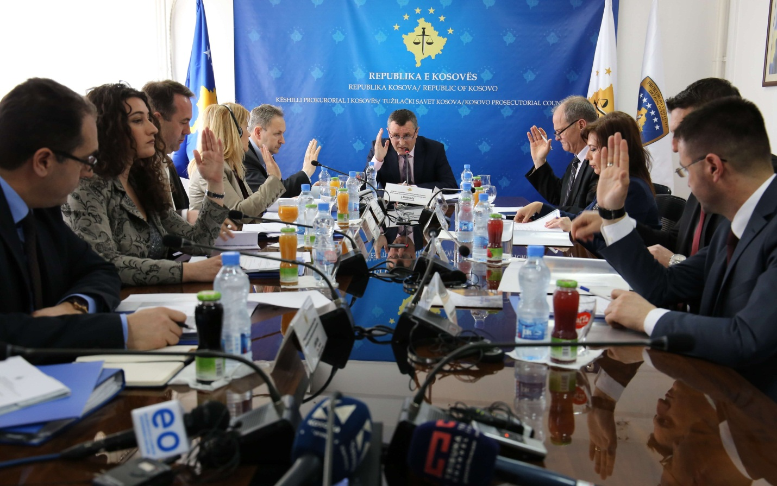

The one-hundred-thirtieth meeting of Kosovo Prosecutorial Council

Prishtina, 9th of March 2017 – There was held the one-hundred-thirtieth meeting of Kosovo Prosecutorial Council (KPC), chaired by the Chairman of Kosovo Prosecutorial Council, Blerim Isufaj.

In this meeting, members of Kosovo Prosecutorial Council have reviewed and approved with some recommendations the Annual Report of Tracking Mechanism on Harmonization of Statistics for 2016.

Members of KPC have also approved the request of Chief State Prosecutor, Aleksandër Lumezi, regarding the transfer of Prosecutor Agron Qalaj from Basic Prosecution in Ferizaj in the Office of Chief State Prosecutor, for a time period from six months.

KPC members have approved the recommendations of the Committee in charge of Transfer and Promotion of Prosecutors in the Special Prosecution of the Republic of Kosova and in Serious Crimes Prosecution Department of the Basic Prosecution in Prishtina. The respective, looks as follows: Prosecutors: Sylë Hoxha, Fikrije Fejzullahu and Florije Salihu Shamolli, shall be transferred in the Special Prosecution of the Republic of Kosova. Whereas, Prosecutors of the Basic Prosecution of Prishtina, Valdet Gashi, Armend Hamiti and Shemsije Asllani shall be transferred from the General Department of the Basic Prosecution in Prishtina to the Serious Crimes Prosecution Department of the respective Prosecution.

As the last item of this meeting was assignment of members from prosecutorial system in the Steering Committee of the Justice Academy of Kosova. Representatives in the Steering Committee of the Justice Academy of Kosova from prosecutorial system shall be: Chief State Prosecutor, Aleksandër Lumezi ex officio; Prosecutor Javorka Perlinqevic, representative of the Basic Prosecution in Prishtina; Lavdim Krasniqi, representative of the Secretariat of Prosecutorial Council; whereas representative of the Appellate Prosecution, Chief Prosecutor of the respective Prosecution, Haxhi Dërguti, shall serve as the member of the aforementioned Steering Committee in a mandate from two (2) years, namely until 2nd of July 2018.

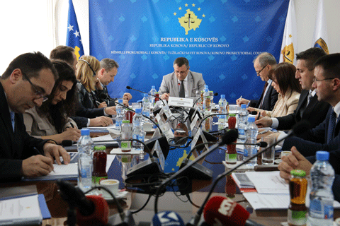

The one-hundred-thirty-first meeting of Kosovo Prosecutorial Council

Prishtina, 29th of March 2017 – There was held the one-hundred-thirty-first meeting of Kosovo Prosecutorial Council (KPC), chaired by the Chairman of Prosecutorial Council, Blerim Isufaj.

In this meeting before members of Prosecutorial Council were presented and approved KPC Annual Reports for 2015 and 2016, reports in which are presented annual activities that have taken place within the accomplishment of the KPC vision and mission.

Today, was also presented and approved the Annual Report of State Prosecutor for 2016, which contains main activities of this Institution with focus on presentation of the work of the Institution through statistical and comparative data.

Another reviewed and approved report by members of Prosecutorial Council was Annual Report regarding the budget of 2016.

Members of Prosecutorial Council have taken the Decision on announcing vacancy for eighteen (18) new positions for Prosecutors, who will be assigned in Basic Prosecutions of Kosova. In the Basic Prosecution of Prishtina and the one Gjilan there is envisaged to assign one Prosecutor in each one of them, in the Basic Prosecution of Gjakova two (2), in the Basic Prosecution of Peja four (4), and in Basic Prosecution of Prizren and Ferizaj one (1) Prosecutor in each one of them.

KPC members have also taken the Decision that the Committee in charge of appointing new Prosecutors shall have the same composition as the previous one. This Committee is composed of Chief State Prosecutor, Aleksandër Lumezi, Chairman; Prosecutor in the Office of Chief State Prosecutor, Lulzim Sulejmani, and Prosecutors Ikramije Bojaxhiu, Radica Milic and Idain Smailji, from KPC, in the capacity of members.

KPC members today have also established the Committee in charge of Prosecutions` Administration. Chairperson of this Committee is assigned KPC member, Prosecutor Radica Milic, whereas members, Deputy Chief State Prosecutor, Sevdije Morina and Prosecutor of the Basic Prosecution in Ferizaj, Veton Shabani.

KPC members today have also approved request of the Victims` Advocacy and Assistance Office on compensation for stand-by duty.

In this meeting were also approved the amendments made by the Normative Acts Committee regarding the Regulation on Election of the Chairperson and Deputy Chairperson of the Prosecutorial Council.

Since the mandate of the current KPC Deputy Chairperson expires at the end of April, KPC Chairman, Blerim Isufaj, in this meeting has invited all Prosecutor-members of KPC to apply for the position of the Deputy Chairperson, based on the normative acts.

As the last item of the agenda was notifying KPC members regarding the resignation of the Prosecutor of the Basic Prosecution of Prizren, Sefer Morina.

Activities of the KPC Chairman

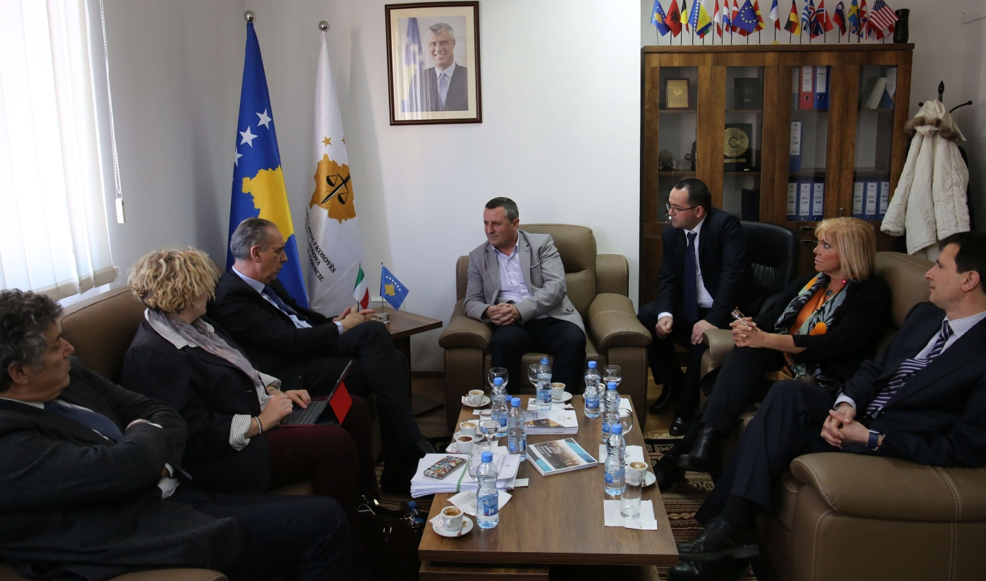

Italian support for prosecutorial system is appraised

Prishtina, 3rd of March 2017 – Chairman of Kosovo Prosecutorial Council, Blerim Isufaj, has hosted in a meeting a delegation from the justice system of Italy, led by the Vice-Head of the Supreme Justice Council of Italy, Giovanni Legnini.

In this meeting, Chairman Isufaj, following the thanking expressed to Italian delegation for the continuous support that Italy is providing for the prosecutorial system of Kosova, has informed them about the organizing of Kosovo Prosecutorial Council, competencies and work that the Council has done and carries on doing.

Chairman Isufaj has also spoken about the Twinning Project financed by EU, “Strengthening Efficiency, Accountability and Transparency of the Judicial and Prosecutorial System in Kosovo”, adding that the Council is working towards benefiting as much from this project, and he has also appraised the work of the engaged Italian experts within the given project.

On the other hand, Vice-Head of the Supreme Justice Council of Italy, Giovanni Legnini, has expressed his will and dedication to share experiences and experiences of the justice system from his country with colleagues of the justice system of Kosova, through the aforementioned project and other cooperation ways.

At the end of this meeting, within the cooperation of both justice systems, Chairman Isufaj was invited for a visit in Italy.

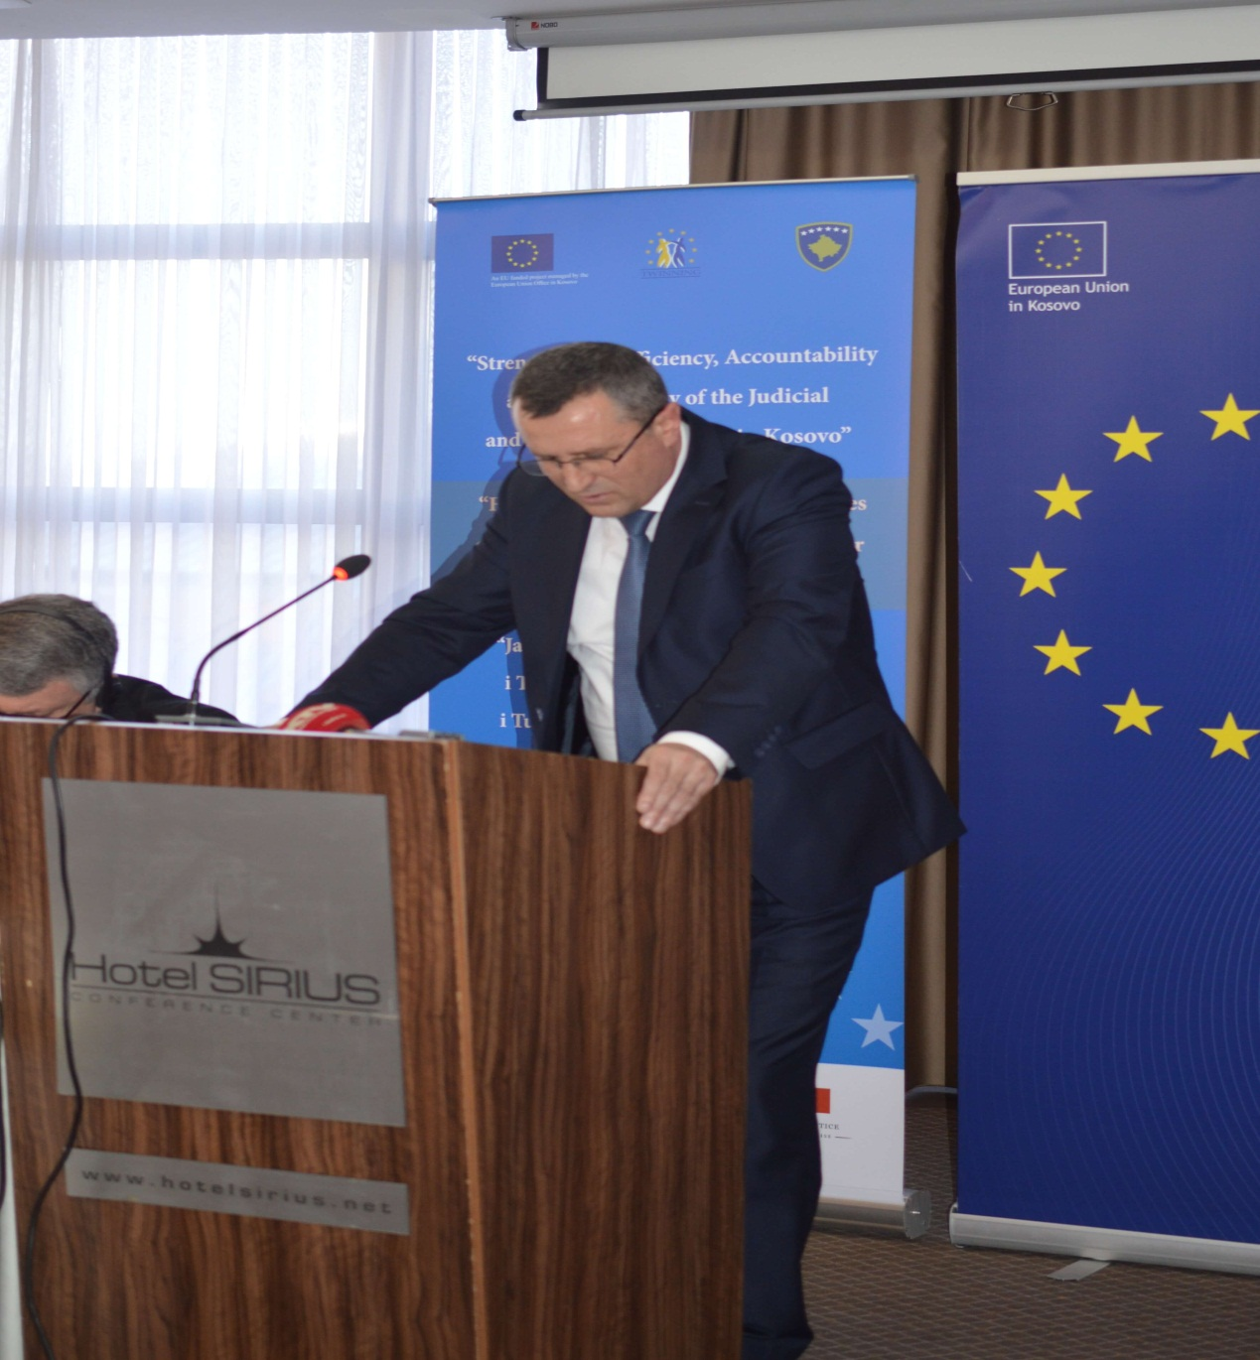

Speech of Chairman Isufaj, at the opening ceremony of the Project “Strengthening Efficiency, Accountability and Transparency of the Judicial and Prosecutorial System in Kosovo”
Prishtina, 3rd of March 2017 – Today, Chairman of Kosovo Prosecutorial Council, Blerim Isufaj, has attended and has delivered a speech at the opening ceremony of the Project “Strengthening Efficiency, Accountability and Transparency of the Judicial and Prosecutorial System in Kosovo"“, managed by EU Office on Kosova, implemented by Italian Supreme Judicial Council and French Ministry of Justice.

On this occasion before the attendees he said: ”It is an honour for me to be present on behalf of Kosovo Prosecutorial Council at the official launching of the Twinning Project.
When I see here important personalities and representatives of main Justice Institutions of friend states, such as Italy and France, as well as those from our country, colleagues from Judicial Council, Ministry of Justice, Chief State Prosecutor, Presidents of the Courts and other guests that are friends of justice system, I feel motivated to have a stronger belief that the project we are promoting today will indeed strengthen efficiency, accountability and transparency of the judicial and prosecutorial system.
For us as benefiters, this project provides opportunities that I am convinced we will use positively.
As already known, now those opportunities are provided to the Council, Council Committees, administrative staff of the Council, as well as for Special Prosecution.
The Project now has started with its activities and is currently at the needs assessment and analysis stage; nevertheless, there are being held trainings and discussions with benefiters` groups, for the purposes of exchanging experiences towards capacities increasing of the prosecutorial system.
I want to emphasize that the project has overcame the challenges of the initiation stage, and we as a Council are giving efforts to cooperate at any time for the best of mutual gaining. This cooperation spirit which is the core of the Twinning Project shall accompany us in the future as well.
The Council, its Committees and administration are going through a positive stage of capacities increasing, therefore the support they are providing and which is expected to be in place from Project Experts is of crucial importance. This is in particular due to the fact that we lack budget to execute activities financed by the Project.
We, with our capacities and support from our partners, are setting advanced standards in recruitment, performance evaluation, transfer, promotion and disciplining of Prosecutors. We believe that experiences shared with us by Project experts and the experience gained by the exchange visits and programs with the Italian and French judicial system shall strengthen further our capacities towards implementation of the constitutional and legal mandate.
As a Chairman of Prosecutorial Council I can freely say that we are giving efforts to offer comprehensive support for Project management and its experts. This is provided by all Council Committees, Secretariat staff, Prosecutors` Evaluation Unit, as well as all Prosecutors.
It is obvious that we have a good start and with the joint dedication I am sure that we will achieve expected successes and that we will accomplish objectives set together.
We are expecting that all activities of the Project, such as: roundtables with experts, exchange programs with Italian and French Judicial Council, as well as study visits in the respective countries, will indeed strengthen efficiency, accountability and transparency of prosecutorial system.
We are aware that those three values are foundation for a genuine Rule of Law and Order in our country and only together we will give a better understanding of the respective to the citizens of Kosova.
We as prosecutorial system have proven so far that efficiency, accountability and transparency are the most important part of our future priorities, and we believe that together we will further strengthen those values.
With hopes that we will carry on the cooperation with the proactive, creative and opened approach, we hope that we will witness that indeed we are promoters of the values which we will strengthen together.
Lastly, I would like to thank European Union for financing this project, EU Office in Prishtina for its management, as well as Italian and French Consortium for its implementation.
We remain opened for cooperation and we believe in the future joint successes.”

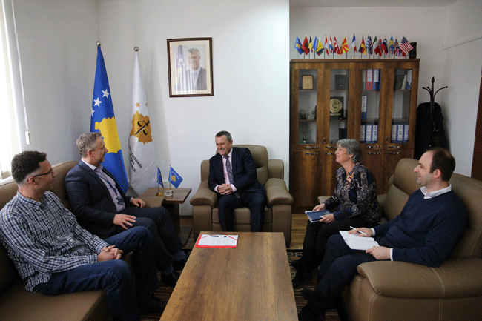

Cooperation between KPC and EULEX is appraised

Prishtina, 9th of March 2017 – Today, Chairman of Kosovo Prosecutorial Council (KPC), Blerim Isufaj, has hosted in a meeting Martin Cunningham, Head of Strengthening Division of EULEX Mission in Kosova.

The discussions in this meeting were regarding the work and cooperation between the prosecutorial system of the Republic of Kosova and EU Rule of Law Mission in Kosova – EULEX, which cooperation between the aforementioned Institutions was appraised by Chairman Isufaj and Mr Cunningham.

Both interlocutors have also expressed their readiness on carrying on and extending the cooperation in the future as well.

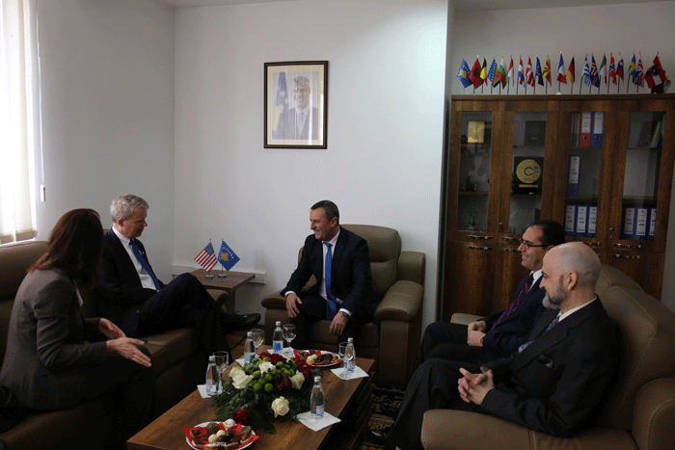
Chairman Isufaj has met with the Ambassador of USA in Kosova, Delawie
Prishtina, 10th of March 2017 – Today, Chairman of Kosovo Prosecutorial Council (KPC), Blerim Isufaj, has hosted in a meeting the Ambassador of the United States of America in Kosova, Greg Delawie, with whom he has discussed about the current state of the prosecutorial system and, the work that has been done by KPC in the last year.

In this meeting the discussions were also regarding recruitment of new Prosecutors in Prosecutorial Office all over Kosova, the transfer of some Prosecutors in the Special Prosecution of the Republic of Kosova, successful identification of Prosecutors of minority-communities for the purposes of their integration in north, and future plans for specialization of Prosecutors who will deal with Domestic Violence cases.

In this meeting, both parties have agreed that Prosecutors present a key component in setting and preserving Rule of Law in Kosova, and that there is still work that has to be done for improving their image in the public.

Chairman Isufaj has promised improvement of the image of Prosecutors through professionalism upgrading and increase of transparency, whereas Ambassador Delawie has thanked the Chairman for his work, and has also expressed continuous support of the USA Embassy, in particular through constant efforts of the US Department of Justice.

Activities of Permanent Committees

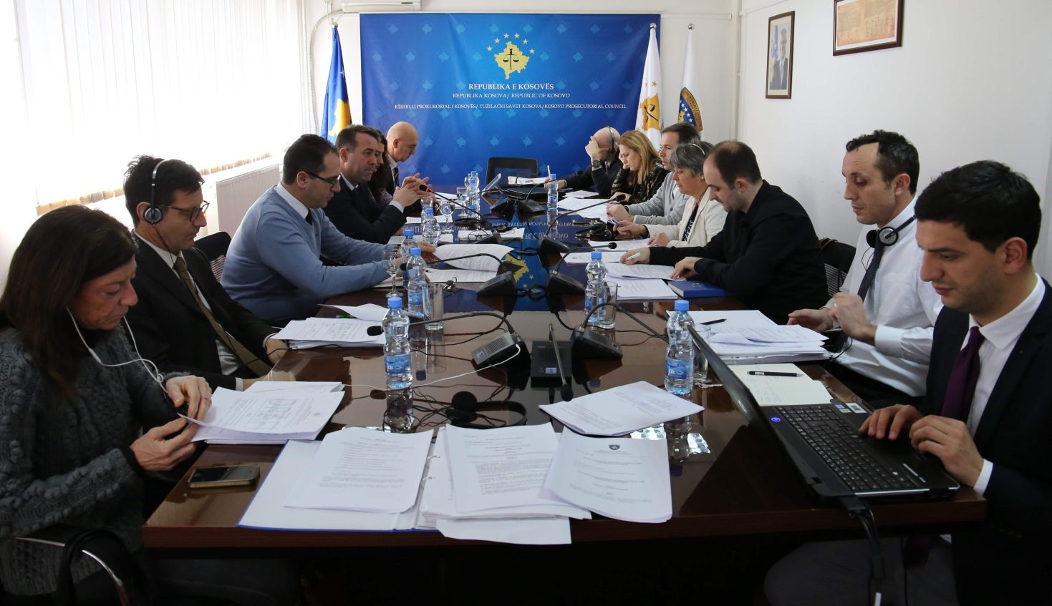

Normative Acts Committee has discussed amending and supplementing of two Regulations

Prishtina, 27th of March 2017 – Normative Acts Committee has held the next meeting in which took place discussions regarding amendment/supplementing of the Regulation no. 09/2015 on the Election of the Chairman and Deputy Chairman of Kosovo Prosecutorial Council and, Regulation no. 03/2016 on the Role and Activity of the Steering Committee of ICT/CMIS Project.

In this meeting, in addition to members of the Normative Acts Committee have participated and representatives of American Embassy, EULEX, and Twinning Project, who are constantly supporting work of the Normative Acts Committee and, the Council in general.

With the consent of Committee members and international representatives there were supplemented and amended Articles 4, 5 and 6 of the Regulation no. 09/2015 on the Election of the Chairman and Deputy Chairman of Kosovo Prosecutorial Council, whereas Article 7 providing temporary provisions, has been decided to be deleted from the current draft. Following the approval of the recommended amendments there was decided to submit the respective draft to Kosovo Prosecutorial Council for approval.

As far as Regulation no. 03/2016 on the Role and Activity of the Steering Committee of ICT/CMIS Project is concerned, the Committee has informed that it has received a request from the Steering Committee of the respective project to amend and supplement Article 5 of the given Regulation. There was also provided information that the recommended amendment has been approved by Kosovo Judicial Council.

Following the discussions by the members of the Committee, with three votes in favour was decided that the named amendments shall be recommended to Kosovo Prosecutorial Council for approval.

Other Activities
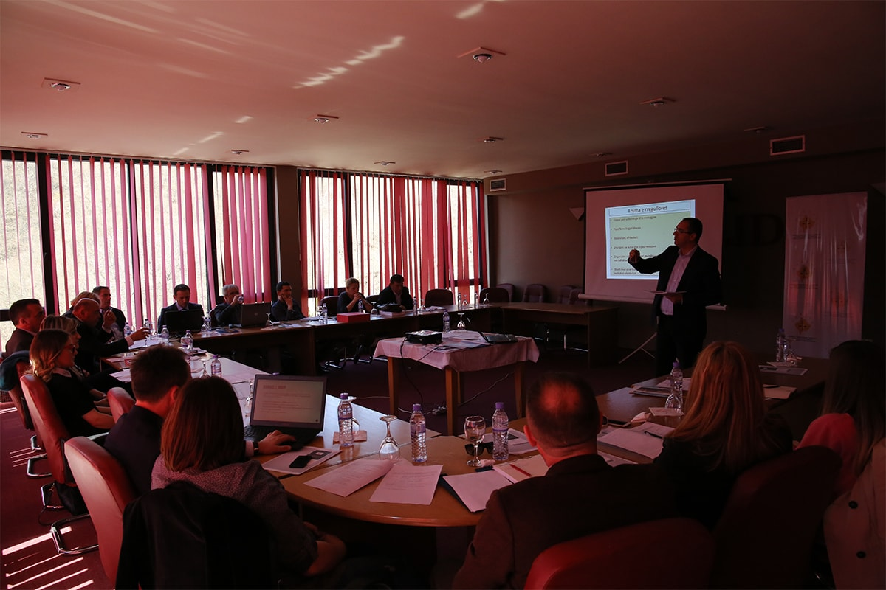

Workshop on capacities developing of the staff of the prosecutorial system of Kosova

Prishtina, 24th of March 2017 – With the support of Kosovo Justice Academy, there was held a workshop “Capacities developing of the staff of the Secretariat of Kosovo Prosecutorial Council (KPC)”, in which are participating Heads of Organizational Units of the Secretariat and Prosecutors` Performance Evaluation Unit of Kosovo Prosecutorial Council, Legal Officers of KPC and of Office of Chief State Prosecutor, as well as other Officers.
In this workshop that will last for two days will be tackled important topics on the functioning of the prosecutorial system of Kosova.
Role of the Secretariat and Unit, planning of job tasks in the spirit of the KPC Action Plan for 2017, shall be topics of this workshop.
In this workshop a special focus will be dedicated to the transparency and resources development for communication with the public, and there shall also be discussed the writing of legal reasoning, and potential financial projects within IPA 2018-2020.

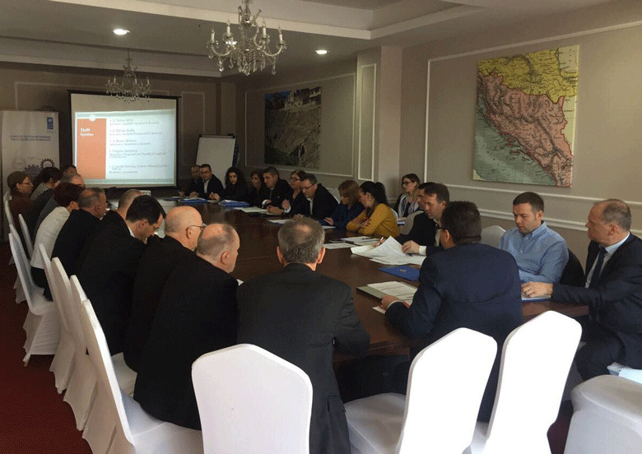

There was held a roundtable between Kosovo Prosecutorial Council, Kosovo Judicial Council and Academy of Justice
Tirana, 31st of March 2017 – Kosovo Prosecutorial Council with Kosovo Judicial Council and Academy of Justice have held a round table in which were discussed topics of joint interests. This round table was held in Tirana under the organizing of United Nations Development Program (UNDP).

In this round table participants have exchanged their institutional experiences regarding the topics of joint interest, for the purposes of increasing their performance effectiveness and efficiency.

Among the topics tackled in this roundtable were: recruitment, performance evaluation and disciplining of Prosecutors and Judges. There were also discussed topics related to capacities upgrading in judiciary and Prosecutions, newness deriving from the Law on the Academy of Justice, the later approved recently, as well as the issue of expertise and administration of Courts and Prosecutions.

Discussions of this roundtable took place through exchange of mutual experiences between Prosecutorial Council, Judicial Council and Academy of Justice, in which the focus of discussions was also on the challenges emerging in their daily work.

For the purposes of reaching implementation of constitutional and legal mandate through inter-institutional cooperation, at the end of this roundtable were brought joint conclusions regarding all discussed topics.

Activities of the Secretariat of Kosovo Prosecutorial Council

Secretariat of Kosovo Prosecutorial Council based on its legal competencies for the purposes of implementing rules, Regulations and policies regarding the management, budget and Prosecutions, during month of March has held different activities.

General Services have conducted constant daily inspection of the premises of the prosecutorial system of Kosova, by intervening in the maintenance of the premises of this system.

Vehicles maintenance servicing was another activity executed by General Services. The respective have also supported systematization of SPRK and Prosecutions` Performance Evaluation Unit Staff in the new premises.

Human Resources have also submitted to the Ministry of Finances request for confirmation regarding budget for positions that will be published upon a vacancy announcement during April of 2017. The respective have also published the vacancy announcement in a deadline from 9 months for the positions of Budget and Finances Officers for needs of Basic Prosecution of Prizren. There were also compiled 9 responds to the requests for maintenance and the respective were submitted to the Ministry of Public Administration, whereas 2 requests were regarding the setting of the salaries code.

Budget and Finances has prepared and submitted to Ministry of Finances, the Medium-term Expenditure Framework for 2018-2020 and, the Report on Financial Liabilities for budgetary organization for the month of February.

Procurement has signed contracts for the projects “Physical Safety of the Premises of the prosecutorial system of Kosova” and “Supply with printers and photocopy cartridges for the needs of KPC”, and there were also executed procurement procedures for the “Supply with window shades for the offices of the premise of Kosovo Prosecutorial Council”.

Information Technology has provided all services requested from the staff of Prosecutions and problems they have faced while using IT equipment and electronic systems.

For the purposes of providing informing regarding the activities that were executed, and the ones that are in the process within the ICT/CMIS Project, were prepared and printed brochures and leaflets.

In the Basic Prosecutions of Ferizaj and Gjilan was provided supply and instalment of simultaneous translation equipment, and there were also set the Translation Booths, and for the purposes of increasing the security level of the premises of Basic Prosecutions was prepared the Plan on increasing number of security cameras and other equipment.

Office for Communication with the Public has followed up the activities of Kosovo Prosecutorial Council, Chairman and Committee for Normative Acts, and other bodies of prosecutorial system, regarding which were prepared Press Releases, the latter distributed to media and uploaded on KPC website. This Office has on daily basis prepared the monitoring of printed, electronic and visual media.

Internal Auditor has carried on the auditing of Victims` Advocacy and Assistance Office (VAAO), on which occasion it has audited regional offices in Prizren and Gjilan, and has prepared the Final Auditing Report for VAAO.

Activities of Prosecutions` Performance Evaluation Unit, functioning within Kosovo Prosecutorial Council

Prosecutions` Performance Evaluation Unit (The Unit) of Kosovo Prosecutorial Council, based on its legal competencies for supporting the Council, during the month of January has held different activities.

Office for Prosecutorial Overseeing, Analytics and Vetting has drafted Annual draft-Reports for Kosovo Prosecutorial Council, Tracking Mechanism and four-analytical draft-report on the inter-institutional tracking mechanism for a four-year time period.

Officers of the Office for Prosecutorial Overseeing, Analytics and Vetting have supported drafting of the Annual Report of Chief State Prosecutor for year 2016, and have supported the performance evaluation process of Prosecutors, as planned by the Action Plan for 2017. This Office has also coordinated and represented itself on the meetings held in Ministry of European Integrations, which were held within the finalization of the ERA (European Reform Agenda) Action Plan and reporting for Stabilization and Association Agreement (SAA).

Office for Statistics functioning within the Unit has prepared statistical data for different criminal cases (PPN), and for cases of unidentified offenders (PPP), thus providing a brief comparative statistical analysis for the aforementioned offenses for years 2012, 2013, 2014, 2015 and 2016.
For the needs of KPC Reporting regarding SAA, there took place the modification of the kriMKorr database, in which were added areas that cover criminal offenses of Corruption related to procurement. The named Office has prepared a statistical report for application of alternative procedures in the Basic Prosecution of Prishtina during 2016. Upon the request of ICT/CMIS Project, for and to the latter were prepared and submitted samples of forms for collecting ways of statistical data. Office for Statistics has received from media and candidates preparing for their academic titles, three requests for statistical data, and to the same it has responded.
Office for Trainings within its cooperation with American Embassy in Prishtina, ICITAP, and Academy of Justice (former- Kosovo Judicial Institute) and Police Academy in Prishtina has organized different trainings for professional upgrading and training of Prosecutors and administrative staff.
Prosecutors have participated in trainings that were tackling topics from different aspects of criminal procedures and material law in the area of criminal offenses of organized crime, human trafficking, violent extremism and terrorism.

