Activities of Kosovo Prosecutorial Council
January 2017
MONTHLY BULLETIN

REPUBLIKA E KOSOVES
REPUBLIKA KOSOVO / REPUBLIC OF KOSOVO
KËSHILLI PROKURORIAL I KOSOVËS/ TUŽILAČKI SAVET KOSOVA/KOSOVO PROSECUTORIAL COUNCIL

Content

Foreword 3
1. Meeting of Kosovo Prosecutorial Council 4
The one-hundred-seventh meeting of Kosovo Prosecutorial Council 4
2. Activities of KPC Chairman 5
KPC receives support for increase of the effectiveness 5
3. Annual Conference of Prosecutors 6
Speech of Chairman Isufaj at the Annual Conference of Prosecutors 6
Pictures: Annual Conference of Prosecutors 9
4. Activities of Permanent Committees 10
Prosecutors` Performance Evaluation Committee 10
5. Activities of the Secretariat of Kosovo Prosecutorial Council 11
6. Activities of the Unit of Kosovo Prosecutorial Council 13

Kosova: Prishtina
Address: Luan Haradinaj, Prishtina, no.16/1 zone II, category II
Tel: 038/200 18 710
Website: www.kpk-rks.org
e-mail: Info.kpk@rks-psh.org

Foreword

For the purposes of promoting communication with the public and, easier access to the work and activities of Kosovo Prosecutorial Council, the latter shall prepare and publish on monthly basis the ‘Bulletin’.

Through this Bulletin, all the interested ones shall be informed about the activities of Prosecutorial Council, its permanent Committees, Secretariat of the Unit, as well as its other sectors.

In the capacity of the Chairman of Kosovo Prosecutorial Council, together with the staff, we are dedicated to carry on with the work and engagement, so the Institution of Kosovo Prosecutorial Council will accomplish all obligations and responsibilities stipulated by the Constitution of the Republic of Kosova, Laws and other bylaws.

Our aim is that Kosovo Prosecutorial Council, as one of the main bodies of the prosecutorial system in the Republic of Kosova, be as transparent, and to establish mechanisms that facilitate access of the public on obtaining information regarding activities and work taking place within the Council.

Thank You!

Blerim Isufaj,
Chairman of Kosovo Prosecutorial Council

Meeting of Kosovo Prosecutorial Council

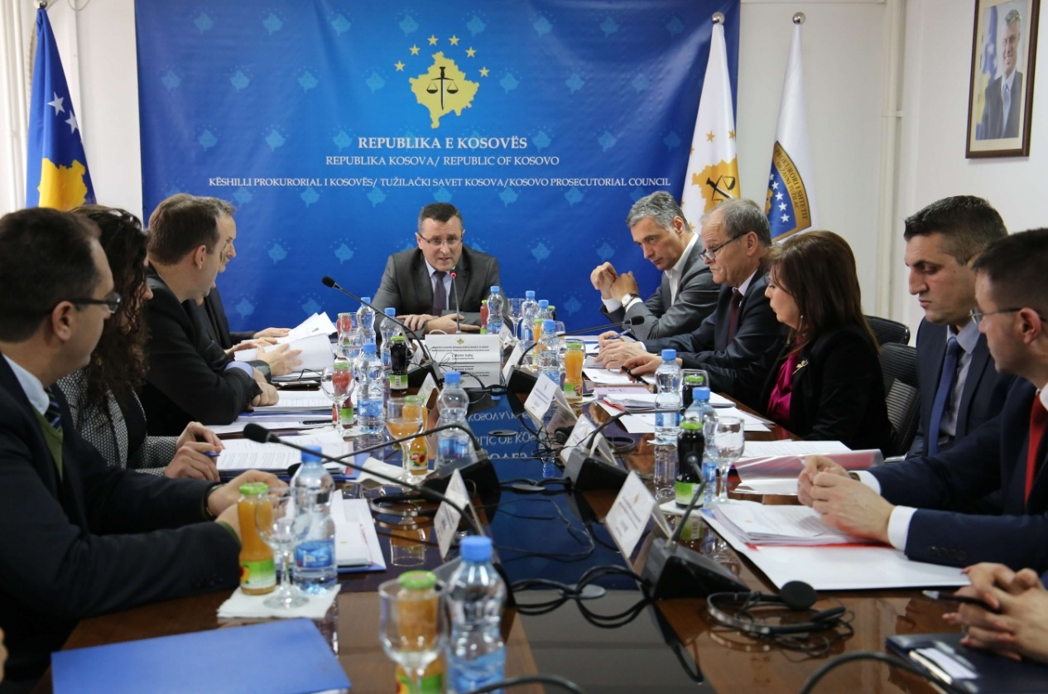

The one-hundred-seventh meeting of Kosovo Prosecutorial Council

Prishtina, 13th of January 2017 – There was held the one-hundred-twenty-seventh meeting of Kosovo Prosecutorial Council (KPC), chaired by the Chairman of Prosecutorial Council, Blerim Isufaj.

In this meeting, members of Kosovo Prosecutorial Council have approved suggestions given by them regarding the Tracking Mechanism on Harmonization of Statistics for the time period January-September 2016.

KPC members have taken the Decision to announce the vacancy for promotion of five (5) Prosecutors in the Special Prosecution of the Republic of Kosova, as well as for three (3) Prosecutors in the Serious Crimes Prosecution Department of the Basic Prosecution in Prishtina.

KPC members have also approved priorities of the Council and its assisting bodies, which priorities will be part of the Work Plan of the Council for 2017, plan that is expected to be approved in one of the next meetings.

At the end of the meeting, members of Prosecutorial Council have approved the request on compensation of the staff engaged during the Election Day for the Mayor of the municipality of Drenas.

Activities of KPC Chairman

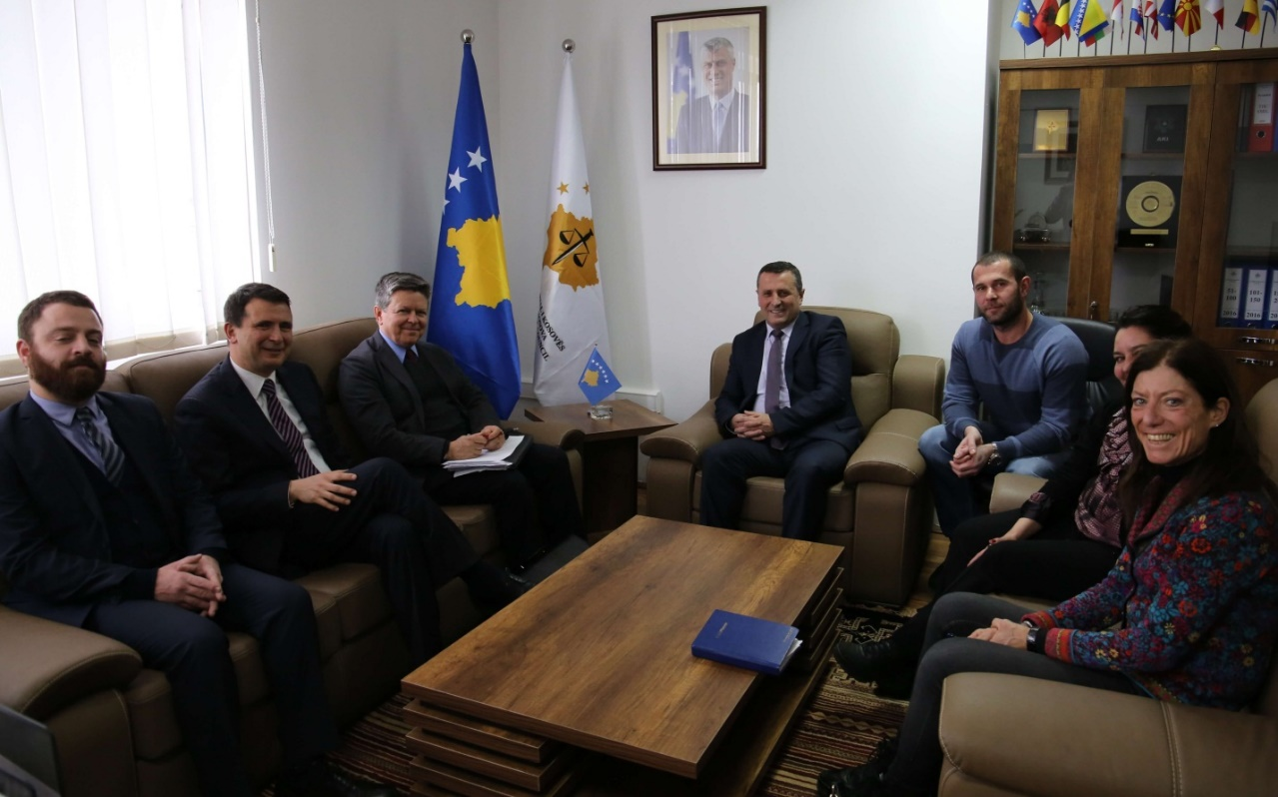

KPC receives support in increasing the effectiveness

Prishtina, 17th of January 2017 – Today, Chairman of Kosovo Prosecutorial Council, Blerim Isufaj, has hosted in a meeting co-leaders of the Twinning Project “Increasing the Efficiency, Accountability and Transparency of the Judicial and Prosecutorial System in Kosova”, Mr Guilio Adilardi and z. Yves Charpenel.

In this meeting, Chairman Isufaj following the briefing of the participants regarding the new structure and work of Prosecutorial Council has expressed his appreciation regarding the objective of this project financed by EU Office in Prishtina. He has also expressed his readiness and readiness of Prosecutorial Council for cooperation in execution of the project.

On the other hand, representatives of the project have said that through this project, prosecutorial system will be supported with their best expertise in achieving planned priorities by Kosovo Prosecutorial Council.

Chairman Isufaj has also presented some needs in which prosecutorial system of Kosova shall benefit through experiences and expertise of the named project.

In this meeting was said that the successful execution of this project will impact increase of the efficiency, accountability and transparency of the prosecutorial system of Kosova.

Annual Conference of Prosecutors

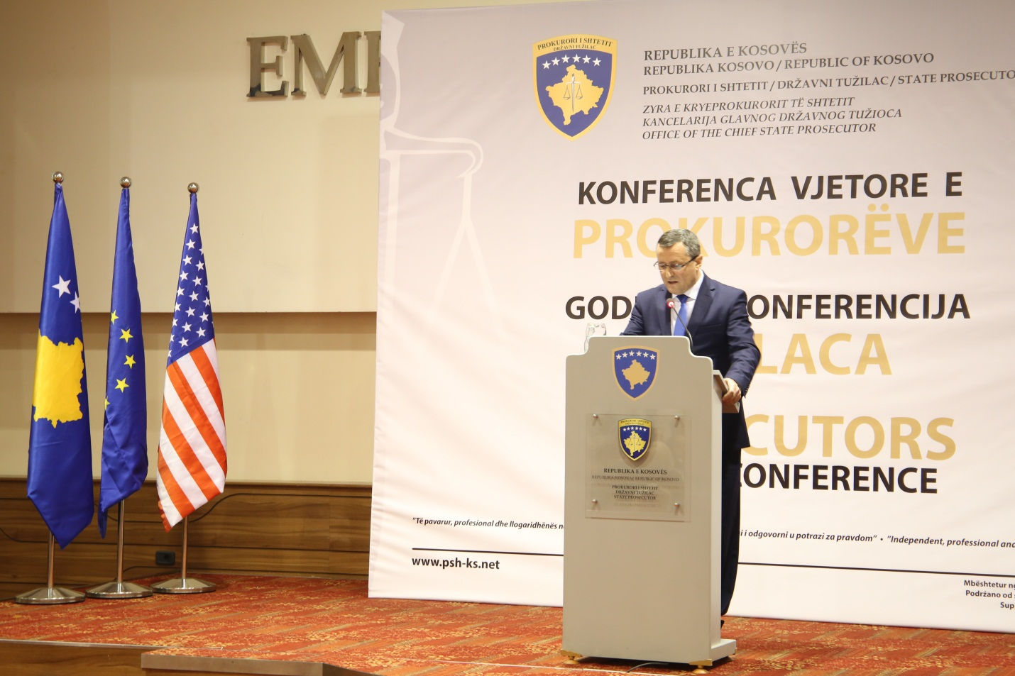

Speech of Chairman Isufaj at the Annual Conference of Prosecutors

Prishtina, 28th of January 2017 – There was held the Annual Conference of Prosecutors, organized by the Office of Chief State Prosecutor.

In this Conference has participated and Chairman of Kosovo Prosecutorial Council, Blerim Isufaj, who before the Prosecutors of the prosecutorial system of the Republic of Kosova and many local and international guests, has held an occasional speech.

On this occasion, Chairman Isufaj before the attendees said: “There is a little bit more than a year when in a similar forum, “Annual Conference” of the last year, I have been elected to represent Special Prosecution of the Republic of Kosova in Kosovo Prosecutorial Council. I thank my colleagues for the trust they have shown to me.

Few days later, the Council has elected me to lead with the Council towards realization of its constitutional and legal mandate. Following this, I have immediately started to feel the weight of leading with the Council, together with its structures.

Since then until now we have gone through many challenges and, today I tell you that I feel proud with the performance of my colleagues who are members of the Council, I am proud with Prosecutors` performance, and with the services provided by the staff of the prosecutorial system, and simultaneously I am motivated from the support provided by all of You, partners of the prosecutorial system.

Our mandate, as the Council is focused on enabling and providing as better working conditions, so, You, Prosecutors can investigate and prosecute criminal offenders, and to efficiently and effectively can represent State against any criminal action or phenomena.

I assure You that your expectations on implementing responsibilities You have, are absolute priority of our Plans and Strategies, as Prosecutorial Council, as well as mine as its Chairman.

I am glad that today I can be certain of saying the following: for a year we have achieved to provide the highest number of Prosecutors, by successfully recruiting 25 new prosecutors, and soon we shall start with recruiting another number of Prosecutors; we have achieved to transfer and promote the necessary number of Prosecutors in different levels of Prosecutions, we have carried on with performance evaluation and disciplining of Prosecutors. The Council has also achieved to recruit vacant positions of the administrative staff envisaged by the Annual Plan for the Staff.

There is worth of mentioning the fact of successful closure of all our obligations deriving from the Brussels Agreement for Justice (recruitment of Prosecutors and supporting staff from non-majority community).

Currently we are working on advancing the system of Prosecutors` performance evaluation, for the purposes of having Prosecutors with integrity, dignity, Prosecutors who are professional and courageous. On this occasion I request from Chief Prosecutors of Prosecutions to be engaged on the fair performance evaluation for each Prosecutor, and together to ensure implementation of the highest performance, honesty and professionalism standards.

We have also constantly promoted system of career development, through transfer and promotion of Prosecutors, where was mostly needed. In the following weeks we will close a promotion process that took place for the purposes of strengthening Special Prosecution and, Serious Crimes Prosecution Department of the Basic Prosecution in Prishtina.

We are working in improvement of Prosecutions` infrastructure, by providing necessary staff, as well as by increasing coordination level for organizing trainings for Prosecutors and staff by Kosovo Judicial Institute.

In our journey we are facing with many challenges, which sometime are difficult ones as well.
We still have insufficient budget for meeting Prosecutors` needs with the needed staff, we still need higher safety and better working conditions, yet, be sure that those needs were addressed to the Government and other partners, and we believe they will support us in achieving fulfilment of our needs.

Our main aims, among others, are improvement of communication, better planning, accountability and transparency. Those and other values are part of our daily activities.

On the other hand, I would like to tell you that Prosecutorial Council has many expectations from you.

Above all, we expect from You Prosecutors to work with dedication, to be fair, independent and professional in conducting your obligations. From you Chief Prosecutors we expect a management with higher standards, conscious, thus, enabling fair access to Prosecution services.

Achievements and execution of our vision would be impossible without the cooperation and support from our local and international partners.

In this regard I shall highlight support provided by different European projects, EULEX Prosecutors and Advisors, Embassies, such as the one of USA, British Embassy, Norwegian Embassy, Embassy of Netherlands, French Embassy, then big support received from UNDP, GIX, IRZ, etc.

By welcoming and appreciating at any time the continuous support provided by our partners, I inform you about the initiative supported by the American Department of State in execution of the project “Initiative for Justice Integrity”., project that will be executed by Kosova Democratic Institute (KDI). This project will be realized through survey conducted on anonymous basis, on which occasion I invite all Prosecutors to positively respond to this initiative.

Prosecutorial Council highly appreciates and cooperation with local Institutions and without wishing to mention any name, I would like to express our readiness for further increasing of this cooperation.

Lastly, I would like to thank all of You for Your contribution, and we expect mutual cooperation in the future as well.”

Pictures: Annual Conference of Prosecutors

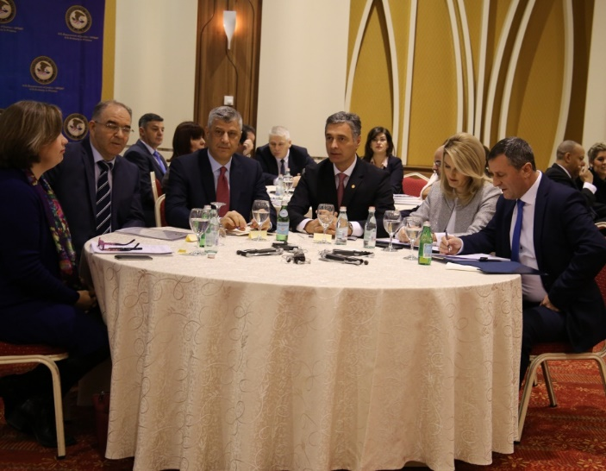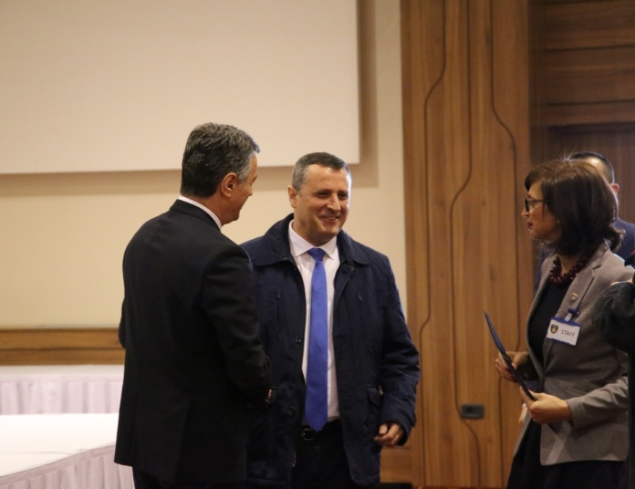

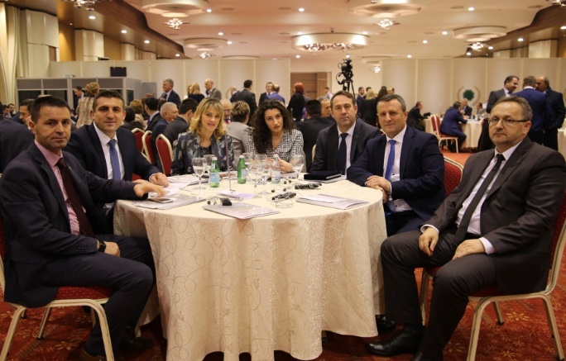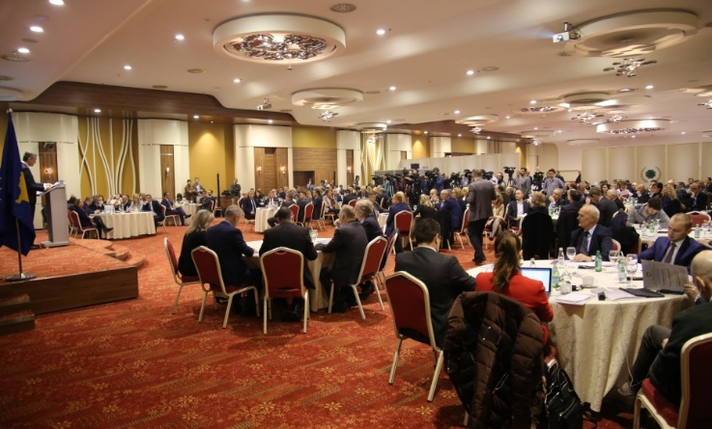

Activities of Permanent Committees

Prosecutors` Performance Evaluation Committee

The Prosecutors` Performance Evaluation Committee has held a work meeting; it has held three official visits in the Basic Prosecution in Prishtina; the latter within the scope of implementation of Prosecutors` Performance Evaluation Regulation within the initiated process of performance evaluation of 20 Prosecutors appointed on the initial mandate.

Members of the Committee have also held two meetings with representatives of the EU Twinning Project “Increasing the Efficiency, Accountability and Transparency of the Judicial and Prosecutorial System in Kosova”.

Activities of the Secretariat of Kosovo Prosecutorial Council

Secretariat of Kosovo Prosecutorial Council based on the legal competencies for supporting the Council on implementation of rules, Regulations and policies’ regarding the management, budget and administration of Prosecutions, during month of January has executed different activities.

General Services have intervened on maintenance of premises of prosecutorial system. Interventions on maintenance of premises are characterized by fixing the heating system, electricity, furniture and so on and so forth.

Based on the requests for supply with expendable and non-expendable materials, supplies took place based on the requests.

Servicing of vehicles, their preparing for usage, entry of the data regarding the fuel expenses and monthly kilometres for all Prosecutions in the same database, were other activities executed by General Services.

Human Resources have conducted recruitment procedures for three (3) positions.

There were prepared data regarding the staff by systematizing the data for year 2016 and, regulating Registration Books and documents for 2017.

There were issued Letters of Appointments for indeterminate time period for the employees that have passed the set deadline of the working time period and, eight (8) Letters of Appointment for indeterminate time period for Legal Officers of the BP in Prishtina.

There was prepared list of Senior Officers regarding the Declaring of the Assets, list that was submitted to the Anti-Corruption Agency, and regarding the same were also informed and recently elected Chief Prosecutors.

Budget and Finances have prepared the Report regarding the Official trips that took place from 2011-2016, for the entire prosecutorial system.

There was prepared the cash flow report and budget commitments for all Offices, and there was prepared the Report regarding the liabilities that have remained from 2016.

There also took place reconciliation with the Treasure of Ministry of Finances, for all economic categories.

Procurement, within its duties and obligations, has carried on with proceeding some projects, as per the requests` submissions from Requesting Units.

There took place the Bid Opening for the Project “Doors Supply for the Offices of Special Prosecution Premise”, and there was also closed the final procurement planning for the fiscal year of 2017, and also as stipulated by the Law on Procurement the respective was submitted to CPA.

There was also closed the Final Report on signed Contracts for the fiscal year 2016.

Information Technology Department has intervened regarding the requests of the prosecutorial system for fixing different issues with IT Equipment.

For the purposes of facilitating electronic communication between the staff, in all computers was installed the Lync chat, and the staff was also trained on its usage.

There was drafted the document on functional peculiarities for Electronic Management of Prosecutors Cases.

The electronic system on management of High Profile Cases was advanced, by managing all Police, Prosecutions` and Courts` activities electronically, as well as instant generating reports.

Within the ICT/CMIS Project were prepared Action Plan for 2017, Trainings Plan on Usage of CMIS and Plan on increasing the IT Staff capacities. Within the project, there were also reviewed functional requests regarding the Case Management Information System.

Office for Public Communication has followed up activities of Prosecutorial Council and Chairman, regarding which it has prepared Press Releases, which in addition were also uploaded on the official KPC website, and on daily basis it has prepared the monitoring of printed, electronic and visual media.

The respective Office has uploaded on KPC website Announcements, Decisions, and other documents and materials. It has also responded to media requests regarding activities of Kosovo Prosecutorial Council.

It has also bound agreement with daily newspapers regarding the publishing of the products of the prosecutorial system of Kosova.

It has also drafted the Action Plan for 2017.

Activities of the Unit of Kosovo Prosecutorial Council

Unit of Kosovo Prosecutorial Council based on the legal competencies for supporting the Council, during January has conducted different activities.

Office for Prosecutorial Overseeing, Analytics and Vetting has drafted the analysis regarding the needed number of Prosecutors, based on the number of cases received during nine (9) months of 2016, and it has finalized the draft of the Action Plan for State Prosecutor for 2017.
For the purposes of preparing peculiarities of the tender, there were also set modules of the database for Prosecutors` files.
The respective has prepared Decision on re-recommending 14 candidates to the President, as per the Brussels Agreement for Justice. There were prepared data on work experience for Prosecutors, within which 15 Prosecutors were also informed regarding Performance Evaluation, and it has conducted visits for selecting eight (8) cases for the purposes of their evaluation.
The respective has also verified the matching between the statistical data regarding characteristic criminal offenses proceeded by the Office of Statistics.
Office for Statistics has prepared statistical reports regarding criminal cases committed by adult offenders, juvenile offenders and unidentified criminal offenders. There were prepared different information/cases regarding which are claims that there were committed criminal offenses; cases regarding which are applied alternative procedures; cases of Appellate Prosecution; and cases of the Office of Chief State Prosecutor.

As far as characteristic criminal offenses are concerned, the Unit has prepared statistical reports for groups of criminal offenses: Weapons, Narcotics/Drugs, Organized Crime, Corruption, Human Trafficking, Smuggling with Migrants, Money Laundering, Economic Crimes (Sequestration and Confiscation of Unlawfully Acquired Assets), Inciting Hatred, as stipulated by Article 147 of the CCK; and the respective data were generated from the kriMKorr database.

The Unit has also prepared special reports regarding cases that are within the scope of European Integrations, and statistical reports of SAA.

There were prepared reports for the Unit in charge of Fighting Corruption and Economic Crimes, and for the Office of National Coordinator in charge of Fighting Economic Crimes and Sequestration of Unlawfully Acquired Assets.

Office for Trainings has coordinated activities regarding the Prosecutors` and administrative staff professional upgrading.

