Activities of Kosovo Prosecutorial Council
February 2017
MONTHLY BULLETIN

REPUBLIKA E KOSOVES
REPUBLIKA KOSOVO / REPUBLIC OF KOSOVO
KËSHILLI PROKURORIAL I KOSOVËS/ TUŽILAČKI SAVET KOSOVA/KOSOVO PROSECUTORIAL COUNCIL

Content

1. Meetings of Kosovo Prosecutorial Council 3
The one-hundred-eighth meeting of Kosovo Prosecutorial Council 3
The one-hundred-ninth meeting of Kosovo Prosecutorial Council 4
2. Activities of KPC Chairman 5
Official visit in the Federal Republic of Germany 5
Focus Groups meetings regarding Corruption Risk Assessment 7
3. Activities of Permanent Committees 8
Execution of the budget for 2016 has been discussed 9
4. Other activities 10
Three-day training for KPC Legal Officers 10
5. Activities of the Secretariat of Kosovo Prosecutorial Council 11
6. Activities of the Prosecutions` Performance Evaluation Unit of Kosovo Prosecutorial Council 13

Kosova: Prishtina
Address: St: Luan Haradinaj in Prishtina, nr.16/1 zona II, kategoria II
Tel: 038/200 18 710
Website: www.kpk-rks.org
e-mail: Info.kpk@rks-psh.org

Meetings of Kosovo Prosecutorial Council

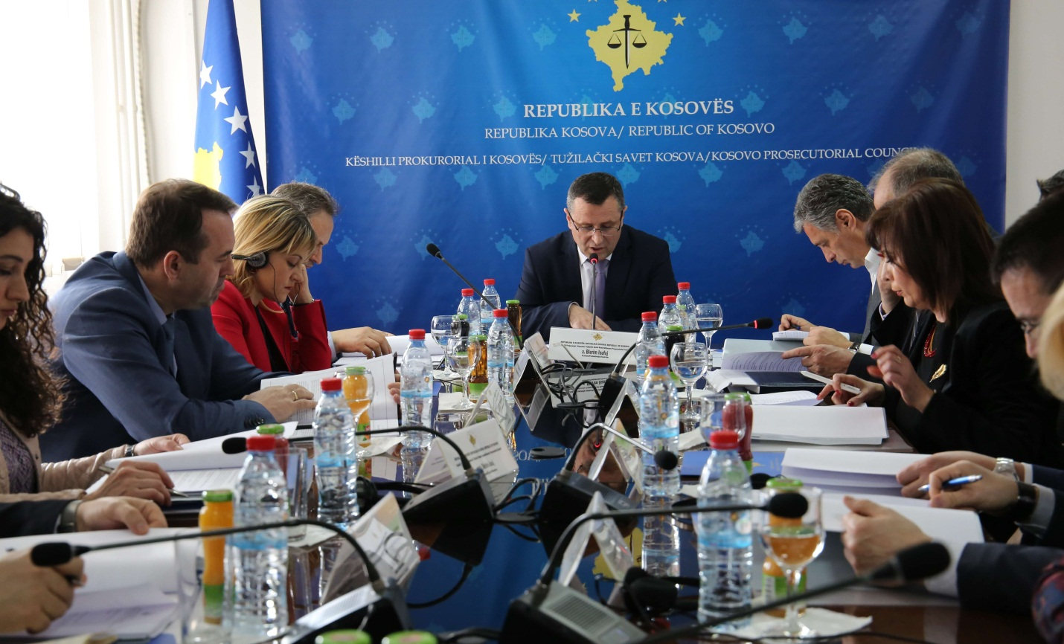

The one-hundred-eighth meeting of Kosovo Prosecutorial Council

Prishtina, 1st of February 2017 – There was held the one-hundred-twenty-eighth meeting of Kosovo Prosecutorial Council (KPC), chaired by the Chairman of Prosecutorial Council, Blerim Isufaj.

In this meeting, members of Kosovo Prosecutorial Council have approved the Report of the Monitoring Committee for Fighting Corruption and Economic Crimes, including sequestration and confiscation, with the propositions and recommendations given by the members of the Council.

In this meeting, KPC members have also established the Committee in charge of transfer and promotion of Prosecutors in the Serious Crimes Prosecution Department of Basic Prosecution in Prishtina and Special Prosecution of the Republic of Kosova. Chairman of this Committee will be Chief State Prosecutor, Aleksandër Lumezi, whereas assigned members are Haxhi Sianaj and Xhevdet Bislimi.

Today, members of KPC have also approved the request of EULEX for approving Prosecutor Ewa Anita Korpi to serve as EULEX Prosecutor.

KPC members have also assigned reserve members of the Committee for Prosecutors` Evaluation Performance.

At the end of this meeting, KPC members have approved transfer of Prosecutor Sylë Hoxha, from the Basic Prosecution of Prizren in the Special Prosecution of the Republic of Kosova for a time period from six (6) months.

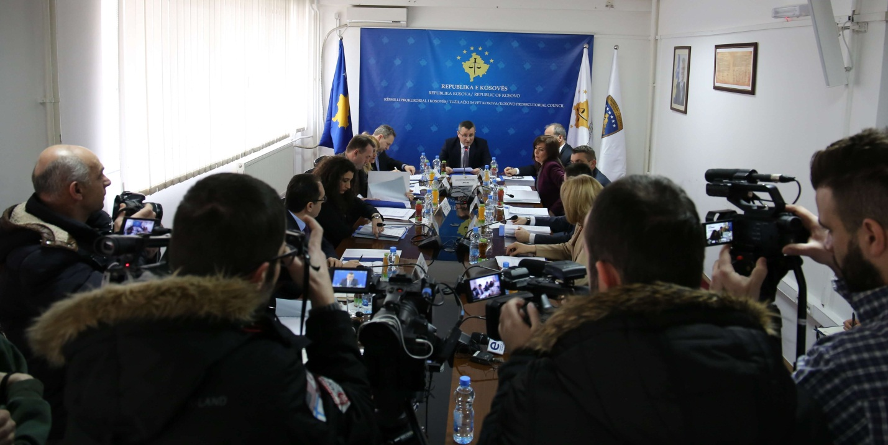

The one-hundred-ninth meeting of Kosovo Prosecutorial Council

Prishtina, 10th of February 2017 – There was held the one-hundred-twenty-ninth meeting of Kosovo Prosecutorial Council (KPC), chaired by the Chairman of Prosecutorial Council, Blerim Isufaj.

At the beginning of this meeting, Deputy Chief State Prosecutor, Sevdije Morina, has informed members of Prosecutorial Council regarding the Action Plan of State Prosecutor, by presenting the goal and objectives envisaged for 2017.

In this meeting, National Coordinator in charge of fighting Economic Crimes, Shqipdon Fazliu, has reported regarding the work done during the time period July-September 2016 and October-December 2016. Following the reporting, KPC members have approved the report of the respective Coordinator, with their remarks and suggestions.

Member of Prosecutorial Council, Radica Milic, has also informed KPC members regarding the Report on implementation of the Strategic Plan for the time period 2016 – 2018.

The last item of the agenda was discussions regarding the KPC Action Plan for 2017, plan that got approved together with recommendations given by KPC members.

Activities of KPC Chairman
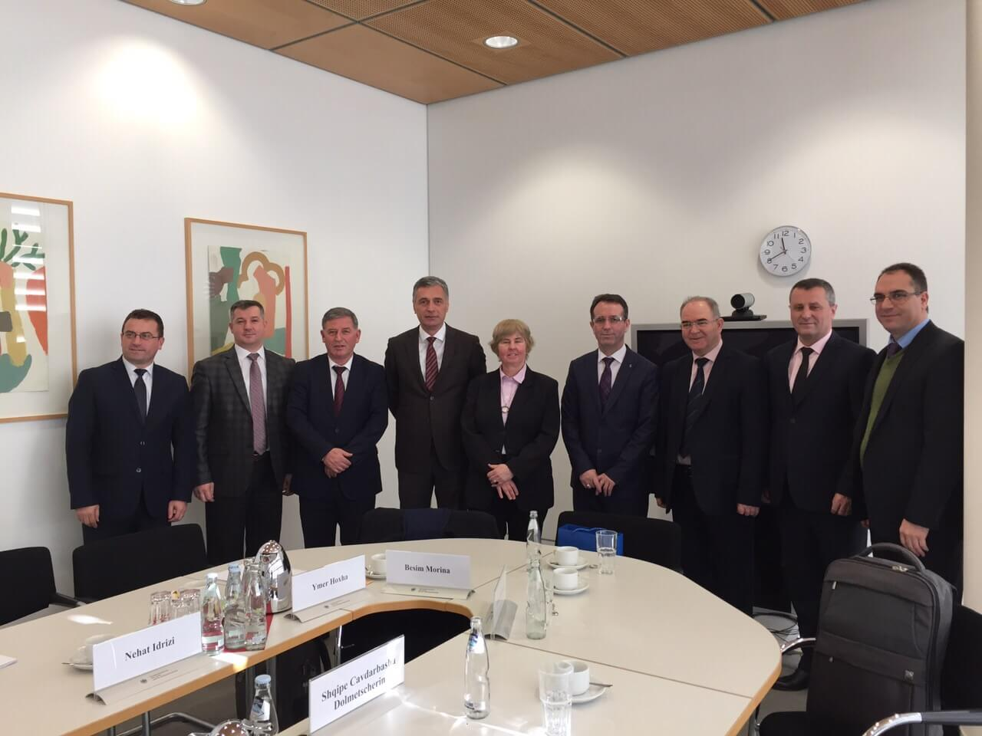

Official visit in the Federal Republic of Germany

Prishtina, 16th of February 2017 – A delegation of the prosecutorial and judicial system of the Republic of Kosova is staying for an official visit in Germany. This visit was enabled from the Twinning Project “Further support for Legal Education Reforms” (Project financed by EU Office), and Kosovo Judicial Institute.

The main purpose behind this visit is getting closely familiar with the functioning ways of regional academies and Federal Academy for Training of Prosecutors and Judges, for the purposes of supporting the transformation process of Kosovo Judicial Institute into Kosova Justice Academy, a process that is being prepared and expected to be realized as soon as the Law approved few weeks ago by the Assembly of the Republic of Kosova, enters into force.
Within this visit were held meetings in the Federal Academy of Trainings for Judges and Prosecutors, Academy of Justice for the Region of Berlin and Brandenburg, as well as Ministry of Justice for the respective regions. Among main topics discussed in those meetings, are: Admission Exams for candidates for Prosecutors and Judges, initial training of candidates for Prosecutors and Judges, Continuous Training of Prosecutors, Judges and Administrative Staff of Courts and Prosecutions, including but not limited to Trainings Needs Assessment, selection of Trainers and Training Methodology.

Part of this visit are also meetings in the Office of Chief Prosecutor and Appellate Court in Berlin, where the discussions were regarding recruitment of human resources, in particular recruitment of new Prosecutors and Judges.

Participants in this visit are also Chairman of Kosovo Prosecutorial Council, Blerim Isufaj, Chief State Prosecutor, Aleksandër Lumezi, Chairman of Kosovo Judicial Council, President of the Supreme Court of Kosova, Head of the Steering Committee of Kosovo Judicial Institute, President of the Basic Court in Gjakova, Director of the Secretariat of Prosecutorial Council, and Acting Director of Kosovo Judicial Institute.

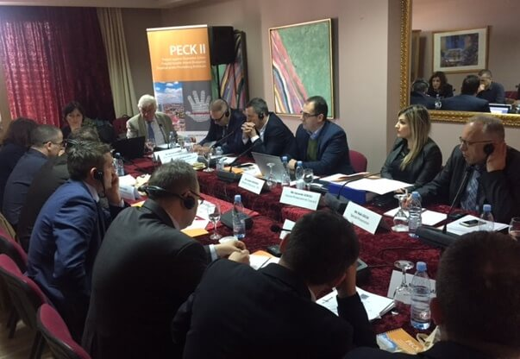

Focus Groups meetings regarding Corruption Risk Assessment

Tirana, 24th of February 2017 – Chairman of Kosovo Prosecutorial Council, Heads of Council`s Committees, Prosecutors and Senior Officers of the Secretariat, are participating in the meetings of Focus Groups regarding the Corruption Risk Assessment throughout Prosecutions and judiciary. Those meetings are organized by the European Union and Council of Europe Joint Project against Economic Crimes in Kosova (PECKII), and will take place on 23rd and 24th of February in Tirana of the Republic of Albania.

Topics of discussion in those meetings are: Prosecutions` management, Prosecutors recruitment, appointment, evaluation and disciplining. There were also tackled and different aspects regarding Case Management, independence of Prosecutors from interference in cases, usage of written guidelines and instructions, Codes of Ethics, treatment of corruption cases from Prosecutors, and decision-making transparency.

For the purposes of exchanging experiences in the capacity of presenters were experts engaged by the project and Prosecutors from Montenegro, Albania and Macedonia. Whereas, participants in those meetings, besides the Chairman of the Council were also Heads of permanent Committees of the Council, Prosecutors from different levels of State Prosecutor, Director of the Secretariat of the Council and, Legal Officers from the Council.

Activities of Permanent Committees
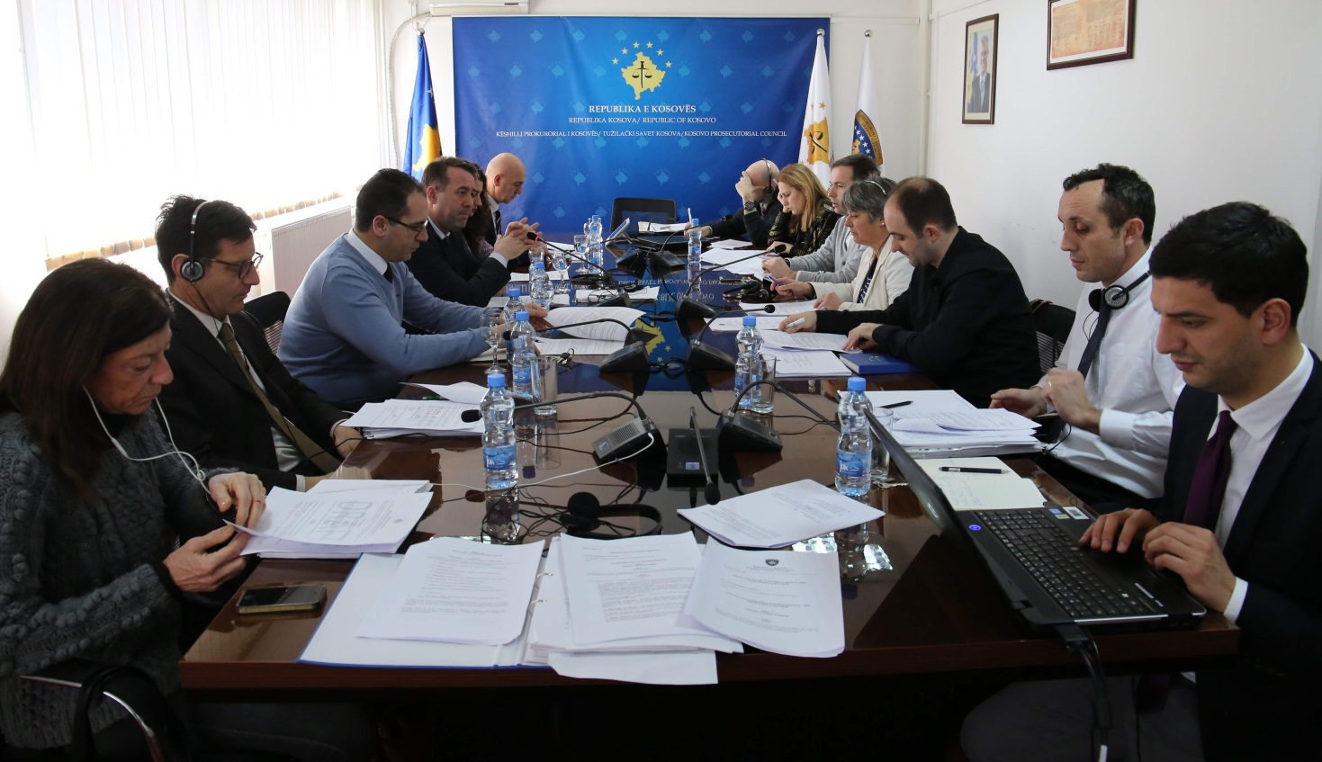

Normative Acts Committee has discussed regarding the drafting of two Regulations

Prishtina, 21st of February 2017 – Normative Acts Committee has held the next meeting in which were held discussions regarding Draft-Regulation on Classification and Declassification of the Documents in the prosecutorial system of Kosova.
In this meeting, in addition to members of the Normative Acts Committee have also participated international representatives from American Embassy, EULEX, UNDP, as well as Twinning Project; the respective have continuously supported the work of the Normative Acts Committee in particular, as well as the one of the Council in general.
During the discussions there was said that classification of documents in the prosecutorial system of Kosova is very important, in particular when bearing in mind the significance and characteristics of Acts issued by Prosecutors during their work.

Upon the proposition of international representatives there was assessed that in addition to the aforementioned Regulation there is also important drafting of the Regulation on Access to the Documents of the prosecutorial system of Kosova, Consequently, in this meeting was established the Working Group in charge of drafting this Regulation, which shall be treated as priority.

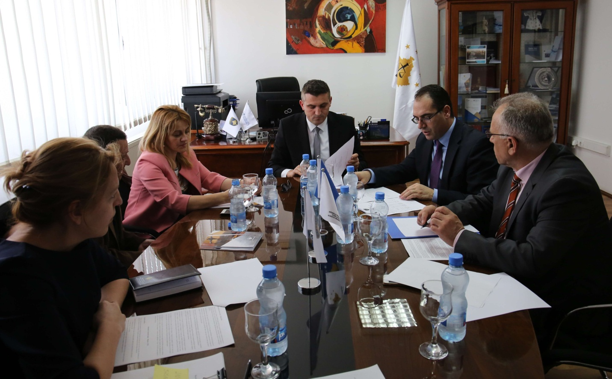

Execution of the budget for 2016 has been discussed

Prishtina, 28th of February 2017 –Committee for Budget, Finances and Staff of Kosovo Prosecutorial Council (KPC), has held the next meeting, in which it has discussed about the execution of the budget for 2016.
In this meeting chaired by the Chairman of the Committee, simultaneously KPC member, Zejnullah Gashi, in addition to the members of the Committee have participated and Director of the Secretariat and, Manager of the Division for Budget and Finances.
The purpose behind this meeting was discussion regarding budgetary amendments that occurred during 2016 for the categories and programs, as well as liabilities transferred in 2017.
In this meeting was decided to prepare a report that would present all budget and finances related activities, in which would be incorporated and execution of the budget for 2016, and the same report shall be submitted to Kosovo Prosecutorial Council.

Other activities

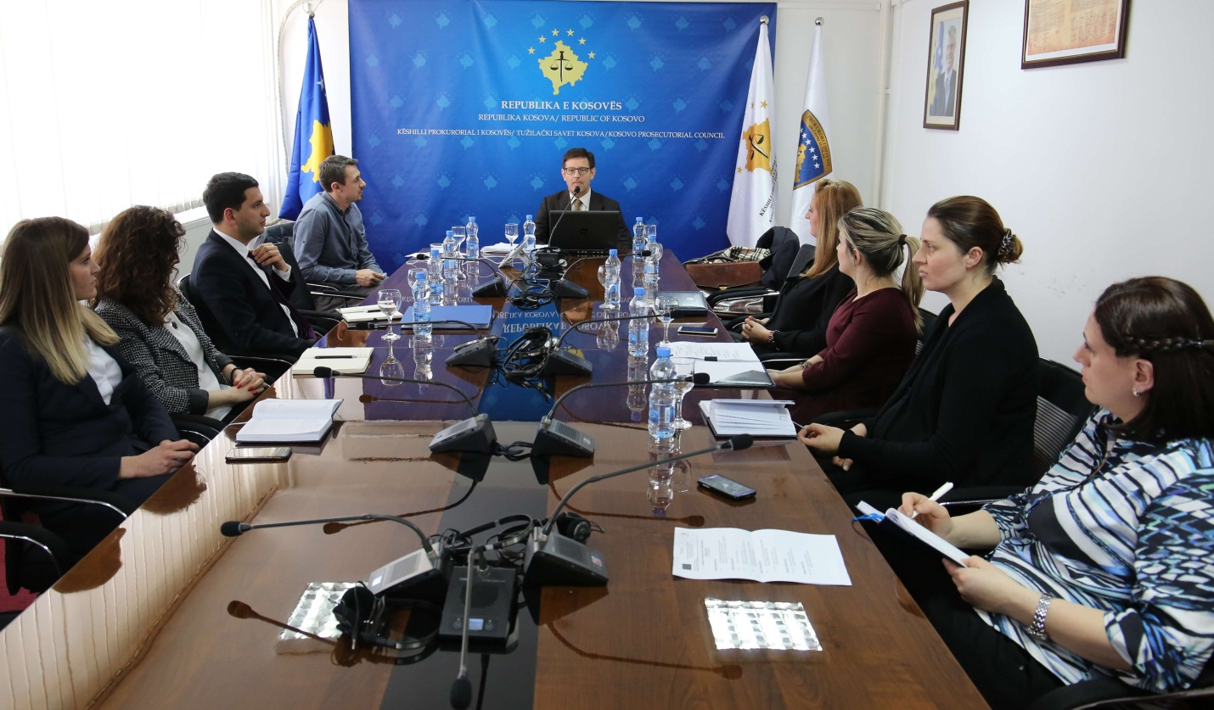

Three-day training for KPC Legal Officers

Prishtina, 22nd of February 2017 - Within the project “Strengthening Efficiency, Accountability and Transparency of Judicial and Prosecutorial System in Kosovo”, there was held the three-day training with KPC Legal Officers.
The training has aimed upgrading managerial capacities of KPC staff, with a special emphasize in drafting Laws, Regulations, Legal Research and budget planning.
The training was provided by the Italian Expert Daniele Cappucio, Judge at the Court of Appeals in the Region of Calabria, who works with organized crime cases. He has a great work experience in the matters regarding the internal organizing, since he has worked for three years in the Legal Department of the Supreme Justice Council in Italy.

Activities of the Secretariat of Kosovo Prosecutorial Council

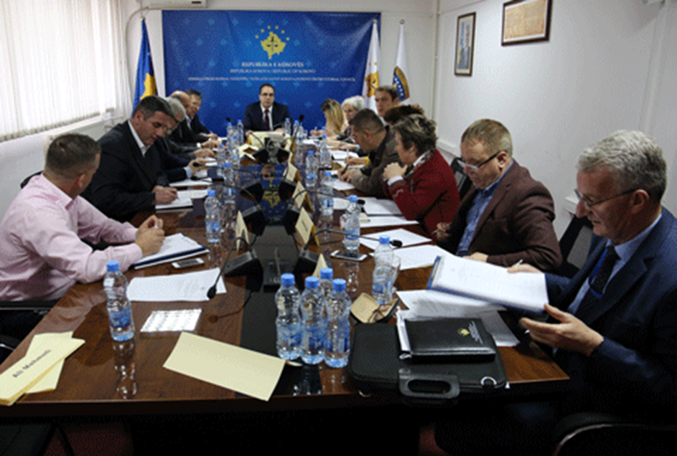

Secretariat of Kosovo Prosecutorial Council based on legal competencies for supporting the Council in implementation of rules, Regulations and policies regarding the management, budget and administration of Prosecutions, during month of February has executed different activities.

General Services have provided continuous daily inspection of the prosecutorial system of Kosova, by intervening in the maintenance of the premises of the respective system.
Servicing of vehicles was another activity executed by General Services. Human Resources have prepared general data of the prosecutorial system for 2016 for the civil employees for MPA needs; they have prepared Decisions on the transfer and have also changed Letters of Appointment for civil servants permanently transferred in the same positions. There were distributed forms on Declaration of Assets for all Senior Officers of the prosecutorial system, and there also took place the update of the database for the entire prosecutorial system.

Budget and Finances Department has submitted to the Ministry of Finances the self-evaluation lists for the Budgetary Organization, Kosovo Prosecutorial Council namely, and there was also submitted the report on financial liabilities for the budgetary organization.

Procurement has executed procurement procedure regarding projects: “Security of the premises of prosecutorial system of Kosova”, “Development, and implementation of the Prosecutors` files electronic management system (SEMDP)”, and project “Supply with printer and photocopy cartridges for the needs of KPC”.

Information Technology Department has provided all services requested from staff and Prosecutions, and has dealt with problems that have emerged during the use of IT equipment and electronic systems.

Together with the company in charge of developing Cases Electronic Management System were reviewed documentation/functional traits, and in Basic Prosecution in Peja and Prizren was provided supply and instalment of simultaneous translation equipment.

As per the requests of Prosecutions there were provided supply with IT equipment.

Office for Communication with the Public has followed up activities of Kosovo Prosecutorial Council and the Chairman of the respective, on which occasion it has prepared Press Releases, and the same were published on the official website of KPC. The named Office has also followed up activities of the Committee for Normative Acts, Committee for Budget, Finances and Staff, and on daily basis it has monitored the printed, electronic and visual media.

During this month, Internal Auditor has audited the Victims` Advocacy and Assistance Office, and he has also audited the needed documents for extracting necessary samples for the respective auditing.

Activities of the Prosecutions` Performance Evaluation Unit of Kosovo Prosecutorial Council

Unit of Kosovo Prosecutorial Council based on the legal competencies of the Council, in January has held different activities.
Office for Prosecutorial Overseeing, Analytics and Vetting based on the number of received cases during 2016 has drafted the analysis on the necessary number for Prosecutors for 2017. The named Unit has also supported the Committee for Promotion and Transfer of State Prosecutors, and it has also received and reviewed two complaints, and it has also drafted Decisions and minutes of the meeting of the Committee in charge of Solving Disputes and Complaints.
Office for Statistics has prepared statistical reports and data regarding 10 Prosecutors subjected to the promotion process. This Office has also prepared statistical reports regarding groups of criminal offenses: Organized Crime, Corruption, Money Laundering and Economic Crimes. The respective reports were prepared for month January and, the respective were prepared for the European Union Office.
It has also prepared statistical reports regarding group of criminal offenses: corruption, violence addressed against journalists, and terrorism.
It has received and has responded to three requests for statistical data for media and candidates working on obtaining academic titles.
Office for Trainings in cooperation with Justice Academy (former Kosovo Judicial Institute), with other national and international agencies dealing with Prosecutors` and administrative staff professional skills upgrading, have organized different trainings. Prosecutors have participated in trainings organized in the area of Criminal Procedure, Material Law and Human Rights, whereas administrative staff has participated in trainings in the area of Human Rights and Management.
Office for Trainings has coordinated activities regarding Prosecutors` and administrative staff professional upgrading.

