REPUBLIKA E KOSOVES
REPUBLIKA KOSOVO / REPUBLIC OF KOSOVO
KËSHILLI PROKURORIAL I KOSOVËS/ TUŽILAČKI SAVET KOSOVA/KOSOVO PROSECUTORIAL COUNCIL
Activities of Kosovo Prosecutorial Council
April 2017
MONTHLY BULLETIN

Content

1. Meetings of Kosovo Prosecutorial Council 3
The one-hundred-thirty-second meeting of Kosovo Prosecutorial Council 3
2. Activities of KPC Chairman 5
Chairman Isufaj has met with representatives of the School of Magistrates of Albania 5
Chairman Isufaj has met with partners that are supporting prosecutorial system 6
Chairman Isufaj and Heads of the Units of KPC Secretariat have discussed the Report of the Internal Auditor 8
3. Activities of Permanent Committees 9
Joint meeting between the Normative Acts Committee and Committee for Prosecutions` Administrations 9
4. Other Activities 11
Reaction regarding threat addressed against Prosecutor Mehdi Sefa 11
Director of the Secretariat has held the next meeting with the staff 12
Director of the Secretariat of the Council has held the next meeting with Administrators of Prosecutions 13
5. Activities of the Secretariat of Kosovo Prosecutorial Council 14
6. Activities of Prosecutions` Performance Evaluation Unit of Kosovo Prosecutorial Council 16

Kosova: Prishtina
Address: Luan Haradina, Prishtina no.16/1 zona II, kategoria II
Tel: 038/200 18 710
Website: www.kpk-rks.org
e-mail: Info.kpk@rks-psh.org

Meetings of Kosovo Prosecutorial Council

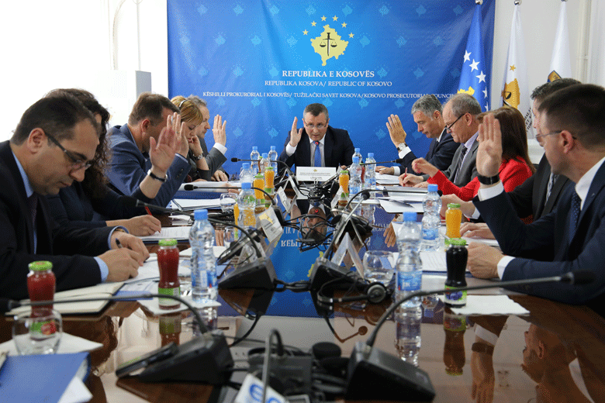

The one-hundred-thirty-second meeting of Kosovo Prosecutorial Council

Prishtina, 25th of April 2017 – There was held the one-hundred-thirty-second meeting of Kosovo Prosecutorial Council (KPC), chaired by the Chairman of Prosecutorial Council, Blerim Isufaj.

In the meeting, members of Prosecutorial Council with nine (9) votes in favour and one (1) vote against have elected Deputy Chairperson of KPC, Prosecutor, simultaneously KPC member, Arben Ismajli. Ismajli shall serve in the position of the KPC Deputy Chairperson for a three-year mandate, whereas his election enters into force on 27th of April 2017.

KPC members have also established the Review Committee. The respective Committee shall be chaired by KPC Chairman, Blerim Isufaj. Whereas, in the capacity of members of this Committee are assigned Deputy Chief Prosecutor, Sevdije Morina and Prosecutor from the Appellate Prosecution, Xhevdet Bislimi. Whereas, assigned reserve members of the Review Committee are, KPC member, Dëshire Jusaj, and Prosecutor of the Appellate Prosecution, Sabri Ademi. KPC has also decided to assign Director of the Secretariat, Lavdim Krasniqi, in the position of Recruitment and Exam Administrator for selection of 18 new Prosecutors.

In today`s meeting, before KPC members have reported regarding the performance of their Prosecutions for the first quarter of 2017, Deputy Chief Prosecutor of the Appellate Prosecution, Sabri Ademi, Chief Prosecutor of the Special Prosecution of the Republic of Kosova, Reshat Millaku. Today have also reported regarding the performance of their Prosecutions for the first quarter of 2017, Chief Prosecutor of the Basic Prosecution in Mitrovica, Shyqri Syla, Deputy Chief Prosecutor of the Basic Prosecution in Gjakova, Ali Uka, Chief Prosecutor of the Basic Prosecution in Peja, Agim Kurmehaj, and Chief Prosecutor of the Basic Prosecution in Ferizaj, Shukri Jashari. The given reports were approved with some remarks and suggestions given by KPC member. There was decided that in the next meeting of KPC shall report regarding the same, Chief Prosecutors of the Basic Prosecutions in Prishtina, Gjilan and Prizren.

KPC members today have also authorized Chairman of Prosecutorial Council, Blerim Isufaj, to sign the Memorandum of Understanding between KPC and KJC.

Activities of KPC Chairman

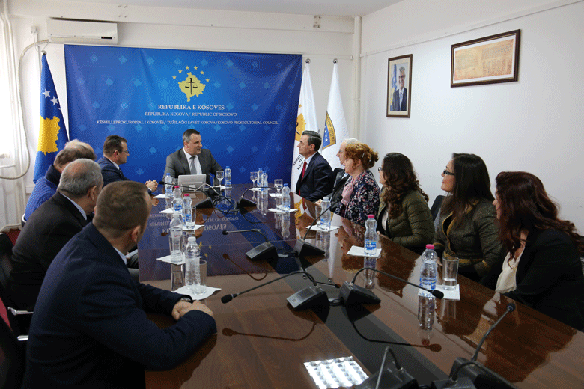

Chairman Isufaj has met with representatives of the School of Magistrates of Albania

Prishtina, 6th of April 2017 – Today, Chairman of Kosovo Prosecutorial Council (KPC), Blerim Isufaj, has hosted in a meeting a delegation from the School of Magistrates of Albania, chaired by the Director of the respective Sokol Sadushi.

On this occasion, Chairman Isufaj has informed the delegation from Albania regarding the reorganizing of the prosecutorial system, as well as structure, competencies, work and activities of Kosovo Prosecutorial Council. He said that KPC manages prosecutorial system of Kosova, starting from the management of the budget, recruitment and selection of Prosecutors, disciplining, promotion, transfer and evaluation of their performance.

On the other hand, Director of the School of Magistrates of the Republic of Albania, Sokol Sadushi, said that the Institution he chairs, deals with recruitment and Initial Educational Programme for the candidates for Judges and Prosecutors, recruitment of candidates for the positions at the Institution of State Attorney, as well as positions such as: Legal Associates, Chancellor of Courts and Prosecutions, as well as Continuous Trainings for the aforementioned positions.

Both interlocutors have appraised the cooperation that was so far in place between prosecutorial system of Kosova and the one of Albania, and they have also expressed the readiness of the Institutions they chair with, for continuing and increasing further cooperation.

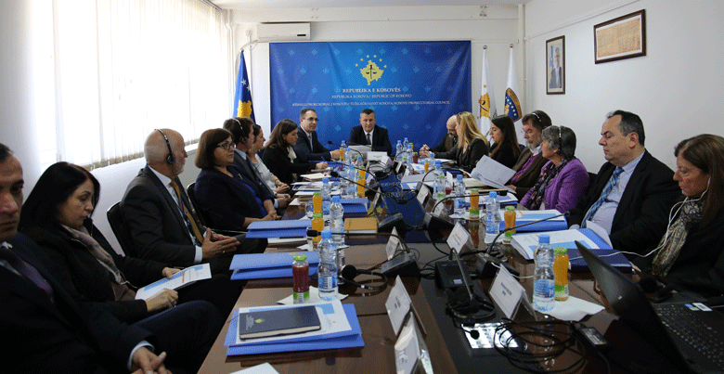

Chairman Isufaj has met with partners that are supporting prosecutorial system

Prishtina, 24th of April 2017 – Today, Chairman of Kosovo Prosecutorial Council (KPC), Blerim Isufaj, has held a coordination meeting with all international donors/partners of the prosecutorial system of Kosova.

This coordination meeting was attended by representatives of America Embassy, British Embassy, Dutch Embassy, EU Office, EULEX, UNDP, Twinning Project, GIZ, EULER II Project, WINPRO III Project, PECK II, etc.

At the beginning of his speech before donors, Chairman Isufaj said that the purpose behind this meeting is expanding cooperation and, briefing regarding the achievements, challenges and objectives of prosecutorial system of Kosova. He said that prosecutorial system of Kosova has marked a tangible progress in many areas within its scope, yet there are present many challenges it carries on to face.

At the end of his speech, Chairman Isufaj has appraised the continuous support provided by international partners of the prosecutorial system, whilst he has also presented his stance regarding as best coordination of donations for the purposes of having as bigger and sustainable benefits from the respective.

On the other hand, Director of the KPC Secretariat, Lavdim Krasniqi has presented priorities of the prosecutorial system. He said that advancement of the administration, management and accountability system, as well as advancement of the Prosecutors` disciplining system, Prosecutors` and administrative staff continuous trainings, promoting public trust in the prosecutorial system, increase of local and international cooperation level, and so on and so forth, are some of main priorities of the prosecutorial system.

On the other hand, representatives of partner Institutions following the appraising expressed for the organizing of the meeting have stated their stances regarding the support they are providing for the prosecutorial system, and they have also presented their opinions concerning priorities presented by the representatives of the prosecutorial system of Kosova.

At the end of the meeting, attendees have agreed that for purposes of better coordination of joint activities, meetings of this kind shall be organized more frequently.

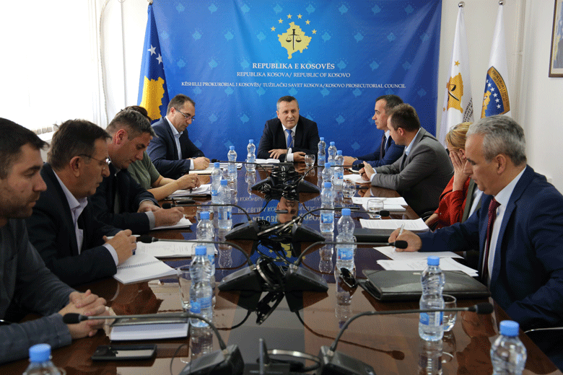

Chairman Isufaj and Heads of the Units of KPC Secretariat have discussed the Report of Internal Auditor

Prishtina, 26th of April 2017 – Today, Chairman of Kosovo Prosecutorial Council (KPC), Blerim Isufaj, and Director of the Secretariat, have held a meeting with Heads of all Units of the Secretariat, in which they have discussed about the findings and recommendations that have derived from the Report of Internal Auditor for 2016.

In this meeting Heads of the Units of the Secretariat have disclosed to Chairman Isufaj their measures undertaken for elimination of findings by Internal Auditor.

On this occasion, Chairman Isufaj has requested as higher engagement from the entire staff of the prosecutorial system in accomplishment of work obligations and duties, in full compliance with laws and other bylaws.

Activities of Permanent Committees

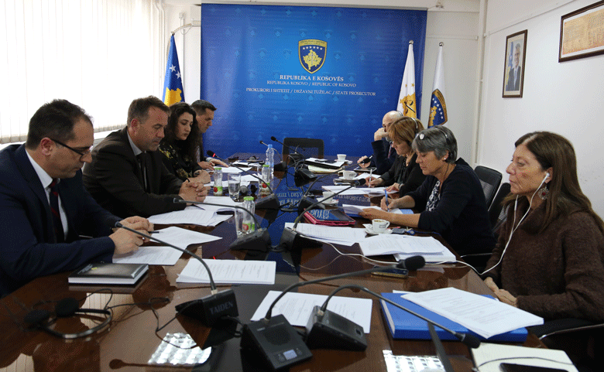

Joint meeting between the Normative Acts Committee and Committee for Prosecutions` Administrations

Prishtina, 20th of April 2017 – Today, Normative Acts Committee and Committee for Prosecutions` Administrations have held a joint meeting in which were discussed Draft-Regulation on Administration of Prosecutions and Draft-Regulation on Classification of Documents and Access to Documents of the prosecutorial system.

In addition to members of both aforementioned Committees, this meeting was also attended by international partners from American Embassy, EULEX and representatives of Twinning Project, who are constantly supporting work of the Normative Acts Committee and, the Council in general.

Initially, attendees were briefed on draft-Regulation regarding the Committee for Prosecutions` Administration, and there took place discussions regarding the respective draft. Draft was supplemented with additional Articles recommended by the attendees, and at the end, following the amending and supplementing of the respective, there was decided that the prepared draft shall be submitted for approval to Kosovo Prosecutorial Council in the next meeting of the latter.
As far as Regulation on the Classification of Documents and Access to Documents of the prosecutorial system, there was said that it shall be discussed in the next meeting of the Normative Acts Committee.

Other Activities

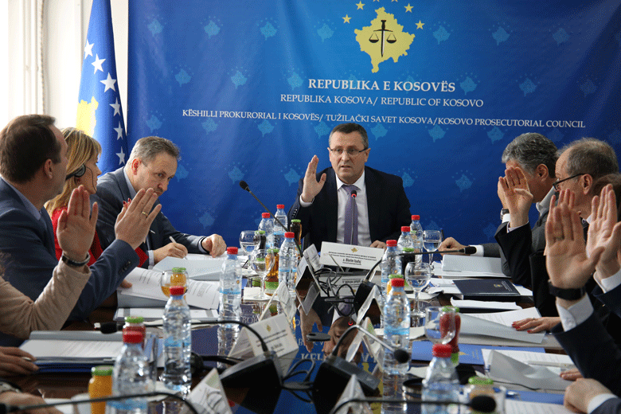

Reaction regarding threat addressed against Prosecutor Mehdi Sefa

Prishtina, 7th of April 2017 - Kosovo Prosecutorial Council expresses its concern regarding threat addressed against Prosecutor of the Basic Prosecution in Prizren, Mr. Mehdi Sefa, threat related to his official duty.

For us as Council, such acts of threats against Prosecutors are intolerable and the same will be taken very seriously. We strongly stand next to Prosecutors, we support them in their daily work and we also encourage them to accomplish their mission.

Kosovo Prosecutorial Council assures the public that this matter is being treated seriously and with the proper emergency level, as this situation deserves to be treated.

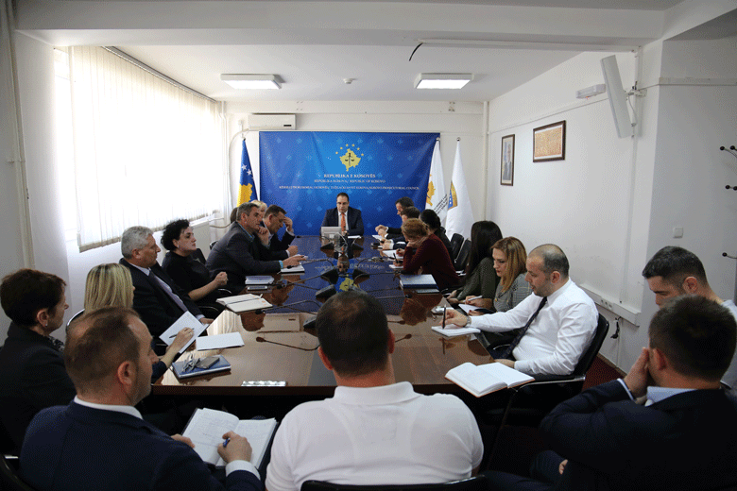

Director of the Secretariat has held the next meeting with the staff

Prishtina, 11th of April 2017 – Director of the Secretariat of Kosovo Prosecutorial Council (KPC), Lavdim Krasniqi, has held the next meeting with the staff of all Units of the KPC Secretariat.

The discussions in this meeting were regarding the works that are being executed within the Secretariat, the progress in terms of the Unit`s Annual Plans accomplishment, and increase of the level of the internal communication.

On this occasion, Director Krasniqi has informed the Secretariat staff regarding the activities that are being executed in all Units, whereas he has requested advancement of the internal communication, for the purposes of what, as he said, effectiveness increase in accomplishment of work objectives.

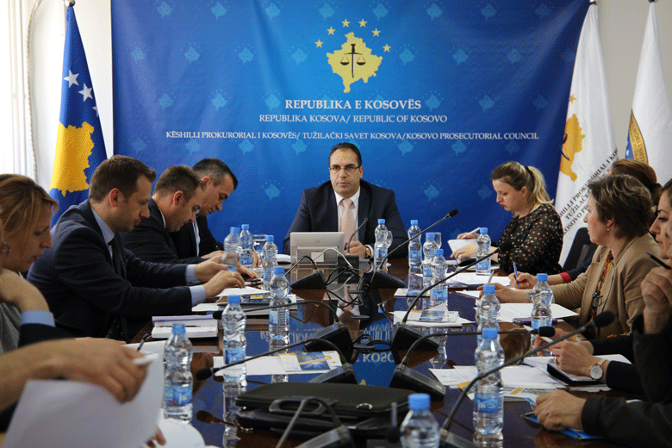

Director of the Secretariat has held the next meeting with Administrators of Prosecutions

Prishtina, 14th of April 2017 – Director of the Secretariat of Kosovo Prosecutorial Council (KPC), Lavdim Krasniqi, has held joint meetings with Heads of the Organizational Units of the KPC Secretariat and Administrators of all Prosecutions.

In this meeting the discussions were regarding the review of the budget for 2017, as well as budgetary requests for 2018. The discussions were also regarding the work and procedures that are being implemented by the Human Resources Division and General Services, and which are related to the requests and needs of Prosecutions.

On this occasion, Director Krasniqi has requested advancement of internal communication, on this case in relation between Secretariat and Administrators, for the purposes of increasing effectiveness in execution of work objectives.

Activities of the Secretariat of Kosovo Prosecutorial Council

For the purposes of implementing rules, Regulations and policies related to management, budget and administration of Prosecutions, Secretariat of Kosovo Prosecutorial Council (SKPC) during April of this year has executed different activities.
General Services have conducted constant daily inspection of Prosecutions` premises in Kosova, by intervening in the maintenance of premises.
Vehicles maintenance servicing was another activity executed by General Services. General Services have also executed other tasks, such as: proceeding cases for supply, registration of cases for supply, registration of cases in the electronic system called e-pasuria (e-assets), etc.

Human Resources have completed the recruitment process for the position of Budget and Finances Officer in SKPC. It has also prepared and published the vacancy announcement for 18 positions, among which positions for Legal Associate, civil and non-civil servants.
There was completed work regarding entering data in the MSHR (Management System of Human Resources), within which were systematized data regarding the employees of the Basic Prosecution of Gjakova.
Human Resources have started implementing Decisions of the Council regarding compensation of the stand-by duty of Victim Advocates.
Budget and Finances have executed reconciliation with the Ministry of Finances regarding all economic categories according to KPC programs. Furthermore, there was submitted to the Ministry of Finances the Financial Liabilities Report of the budgetary organization for month of March.
Procurement has conducted procurement procedures regarding projects: “Supply with Hardcover Folders with Rope Binders –Size B4”, “Supply with potable Water for the needs of the Basic Prosecution in Prishtina“, “Supply with exclusive bookshelves made from natural wood for the needs of the Cabinet of Chief State Prosecutor” and there was signed the contract for the project “Developing, implementing the electronic management system of Prosecutors` Files (EMSPF)”.
Information Technology has provided all services required from the staff of Prosecutions, and they have also assisted for solving problems staff has faced during the usage of IT and electronic systems` equipment.
Within the ICT/CMIS Project were reviewed special features of cases management information system in Prosecutions, and there was also prepared architecture of the system. There was also developed the prototype of the cases management information system.
The Project, for the purposes of informing the staff of the prosecutorial system regarding the activities, has prepared the Plan on presenting activities that were conducted and the ones that are in the process. The respective presentation took place in the Basic Prosecution in Prizren and during May it will also take place in other Prosecutions.
In the Special Prosecution of the Republic of Kosova took place supply and instalment of simultaneous translation equipment and there were also installed translation booths.
Office for Communication with the Public has followed up activities of KPC, Chairman and Committee for Normative Acts, as well as other bodies of the prosecutorial system, and for the respective it has prepared Press Releases and has also published the named on KPC official website. This Office has on daily basis conducted monitoring of the printed, electronic and visual media.
Internal Auditor has started auditing Division of General Services.
Auditor has also conducted meetings with KPC Chairman, Director of the Secretariat and Heads of Departments and Divisions, in which meetings were tackled recommendations of the Internal Auditor for 2016.

Activities of Prosecutions` Performance Evaluation Unit of Kosovo Prosecutorial Council

Prosecutions` Performance Evaluation Unit (The Unit) of Kosovo Prosecutorial Council based on its legal competencies for supporting the Council, during April has held different activities.

Office for Prosecutorial Monitoring, Analytics and Vetting has updated Prosecutors` files, including the database in terms of Prosecutors` data, and the named Office has also drafted Action Plan for Prosecutors` Recruitment Process.

The named Office has drafted Annual Draft Report of the Tracking Mechanism for 2016, whilst it has finalized the quarter report for the time period January-March 2017 of the Inter-Institutional Tracking Mechanism.

Office for Statistics functioning within the Unit has completed statistical reports regarding the performance of Prosecutions for the time period January-March 2017 and it has integrated statistical data from the KrimKorr database from all Prosecutions, and has also completed Statistical Reports regarding characteristic criminal offenses.
The named Office has completed special statistical reports for EU Office, regarding the European Integration and Stabilization Association Agreement.
It has prepared statistical data regarding different criminal cases (PPN) and cases of unidentified criminal offenders (PPP), and as per the request of EULEX it has also compiled a short comparative analysis regarding those criminal offenses for 2012, 2013, 2014, 2015 and 2016.
It has also prepared a statistical report regarding types of Court Decisions concerning accusatory instruments employed by Prosecutions for the criminal offenses submitted by Anti-Corruption Agency.
It has prepared statistical reports regarding the performance of 16 Prosecutors, who are subjected to performance evaluation process and, it has also monitored process of statistical data harmonization between Prosecutions, Courts and Law Enforcement Authorities for April of 2017. It has also prepared statistical data as per the request of NGOs: KDI, FOL and Çohu.
Office for Trainings in cooperation with American Embassy Office in Prishtina, ICITAP, Justice Academy (former Kosovo Judicial Institute), have organized different trainings for professional upgrading and training of Prosecutors and administrative staff.
Prosecutors have attended trainings covering different aspects of Criminal Procedure and Material Law regarding criminal offenses of organized crime, Human Trafficking, Witness Protection, Rights of Defendants, Violent Extremism and Terrorism.

